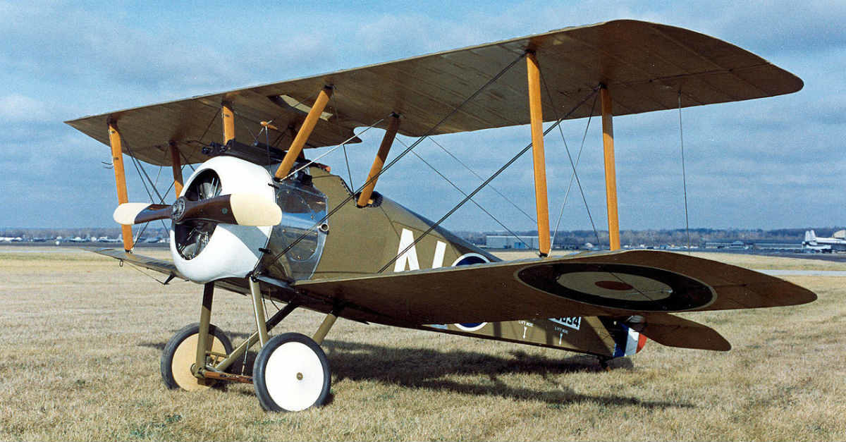

Be the First Nation to own a squadron of planes! This new invention could prove invaluable for observation of enemy positions and if you can figure out how to aim them may be useful as a fighting machine.

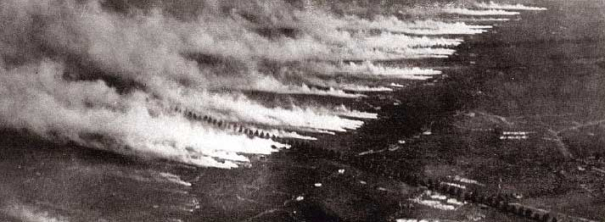

**Chlorine Gas**

Don't let the international ban on this weapon stop you. Buy some today! Use it to burn the eyes and lungs of your enemy before you launch an assault. Just think how easy it will be to conquer your foes when they can't see or breathe. Act now and we will include some mustard gas for free of charge!

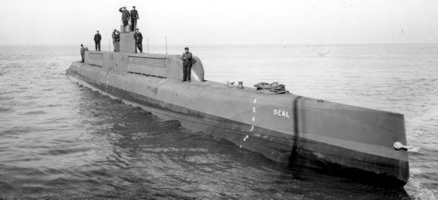

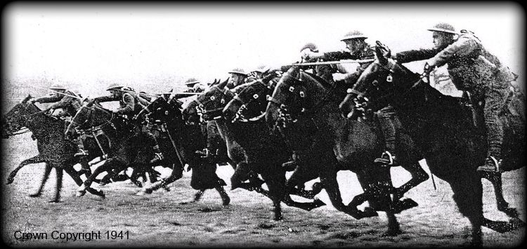

**Cavalry**

What's war without a good ol’ fashioned, gallant and heroic cavalry charge? Ram into your enemy at lightning speed and don't forget to do some slashing with your sword as you cut through enemy lines. Don't let this valuable resource go to waste. Pick up cavalry units today! There are no finer or braver soldiers than those on horseback .

**Submarines (U-Boats)**

Use this weapon to sneak up on the ships of your enemies. Slam a torpedo or two into their sides and sneak away undetected. No muss, no fuss. This is the perfect weapon to use if you want to choke off the supply line of a rival nation. Starve the enemy into your submission by taking out ships bound for their ports. You may not need a dreadnought to rule the waves if you have enough submarines.

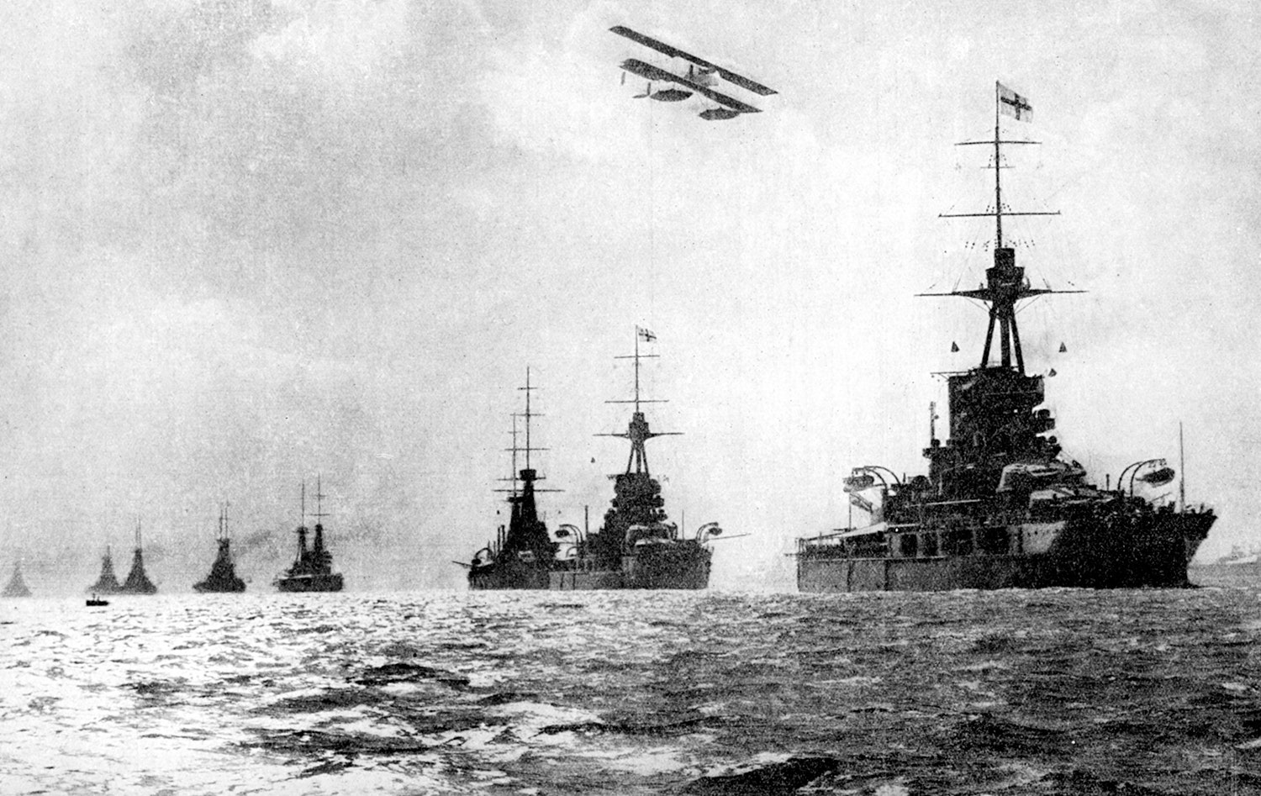

**Dreadnought (Battleships)**

Don't be the last nation on earth to own one of these majestic and powerful weapons! Rule the waves at top speed and with immense power. With a boat this powerful, you can't go wrong

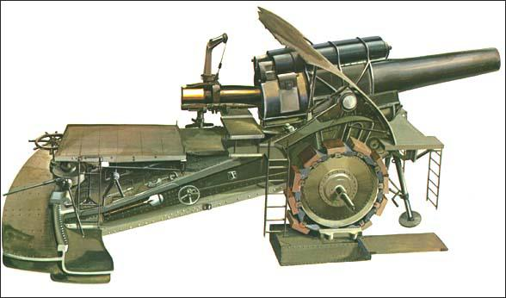

**Artillery (Big Bertha)**

Why fight your enemy face to face when you can shell them from miles away? Use your artillery to your advantage. Sit back, relax and bomb your enemies into submission. Act now!

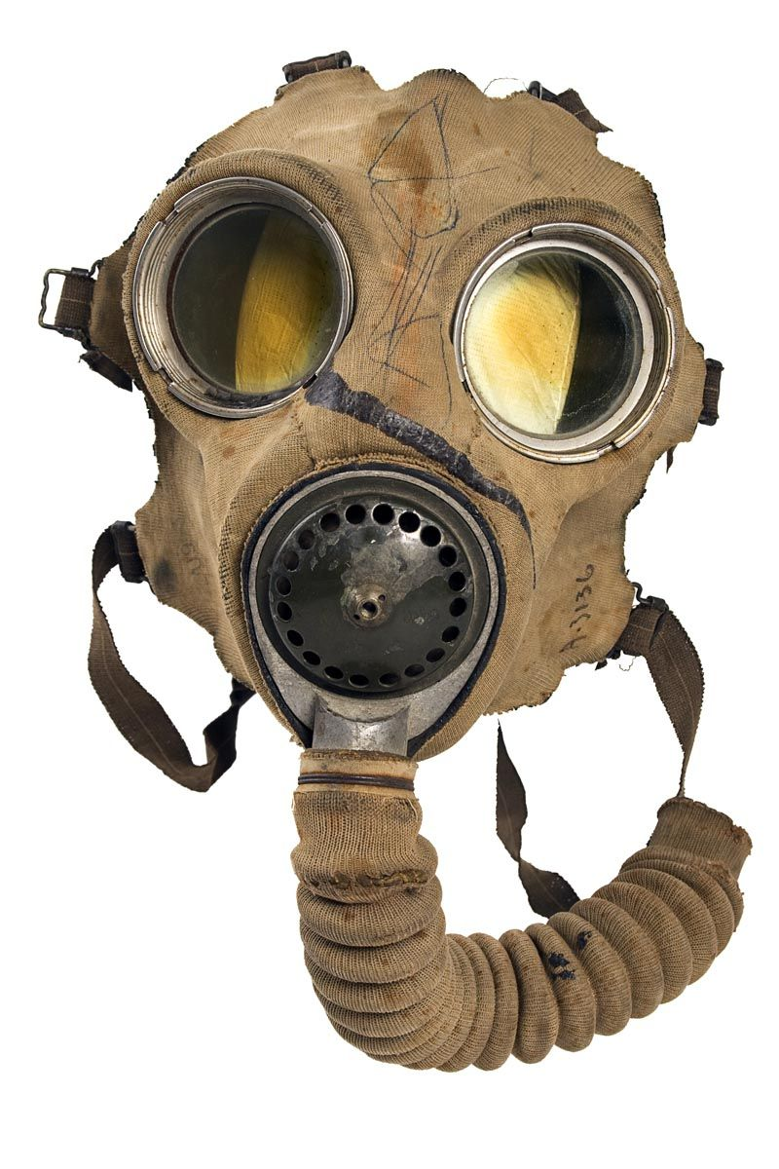

**Gas Mask**

Even when you fail to win chlorine gas in this auction you'll be fit as a fiddle with these gas masks let your enemy unleash their terror weapon sit back and let your legs rest as clouds of poison gas around you then surprised and attacking me with your army ready to defend your lines.

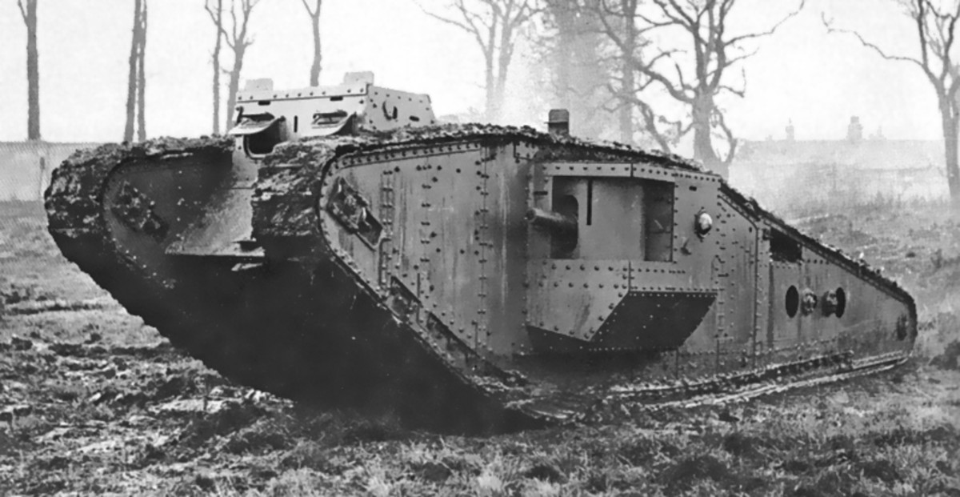

**Tanks**

Another new invention…. this machine has loads of potential. Think of it as moving fortress. It comes equipped with 2 cannons & machine guns. If this machine doesn't scare your enemy into submission, then we don't know what will.

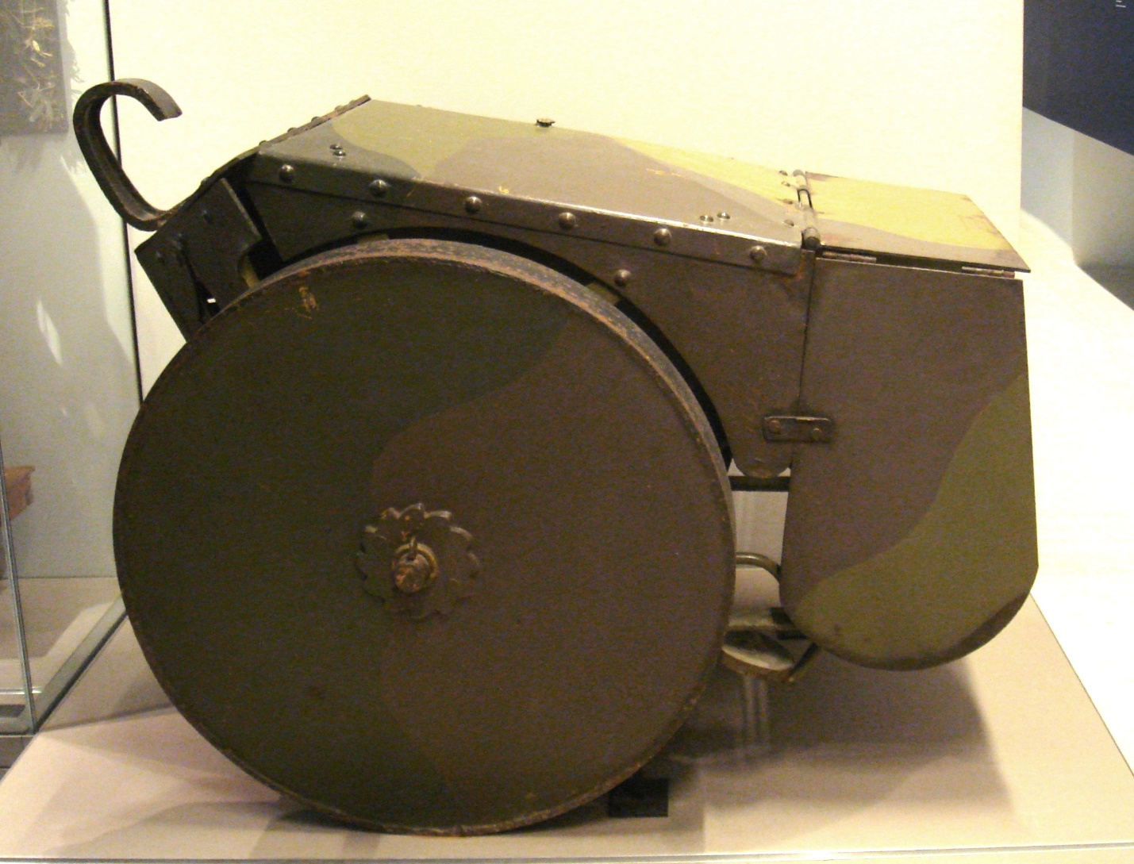

**Mobile Shield**

Worried about exposing your body to an assault? No worries here! Check out this mobile shield! As bombs and bullets whizz by, your army will safely crawl across the battlefield protected. Nothing can stop your men with this practical invention

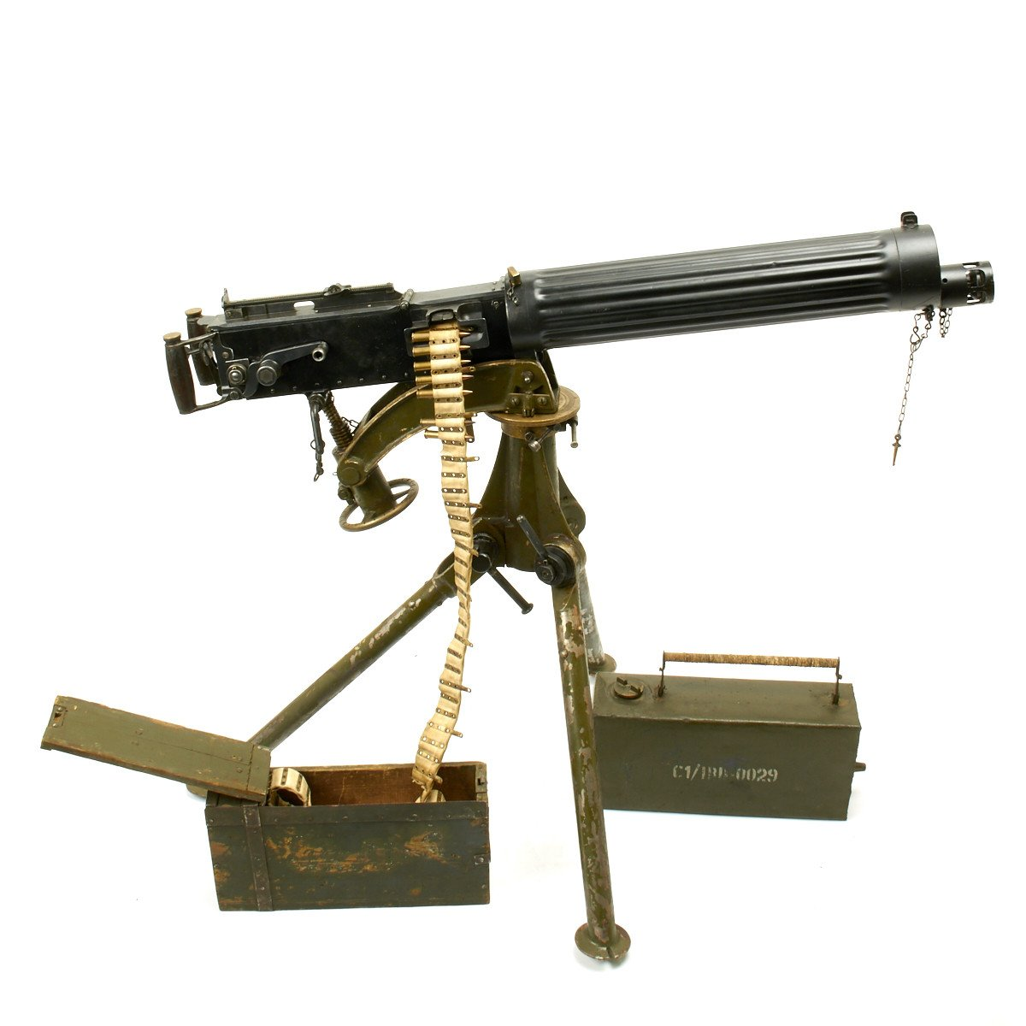

**Machine Gun**

This new invention comes to us compliments of Hiram Maxim. Rain bullets upon your enemies at the rate of hundreds of rounds per minute. Some say a good defense is the best offense. Well, there is no finer weapon for defense than the machine gun, try one today!

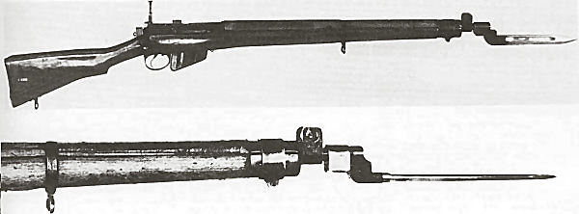

**Rifles**

Long gone are the days of single shot rifles. No more reloading after each shot these repeating rifles are the way of the future. They make excellent long-range rifles as well as adequate short-range killing tools. Attach your bayonet to the end and you have a small spear to stab your enemy. No army should be without this weapon!

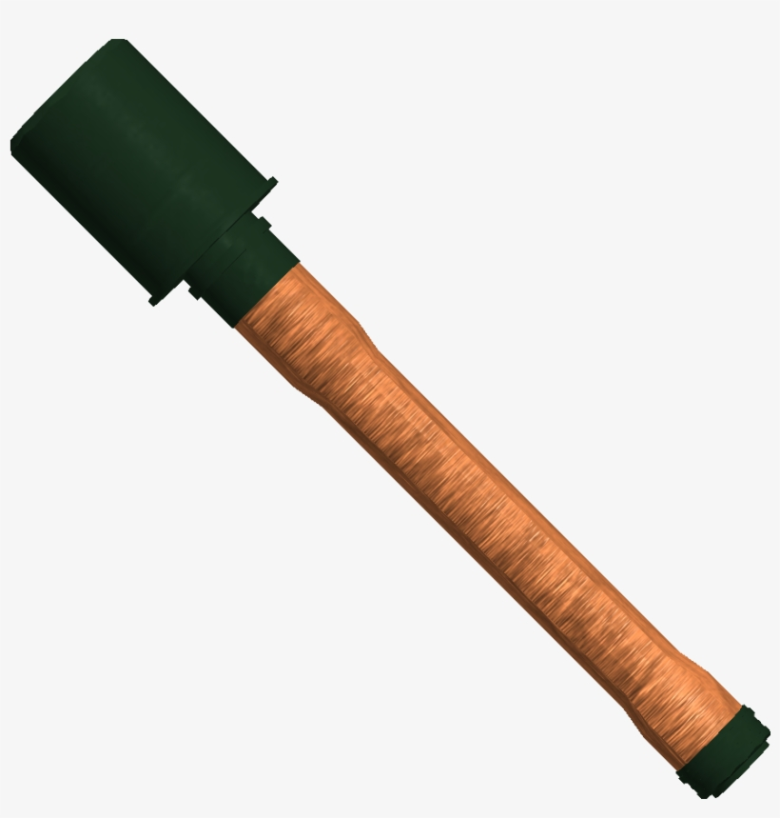

**Grenades**

Get close to your enemies and lob a few of these mini explosive devices into an enemy trench. Lightweight and fantastically fun, these invaluable explosives will surely take off a limb or two of your enemy or machine gun position.

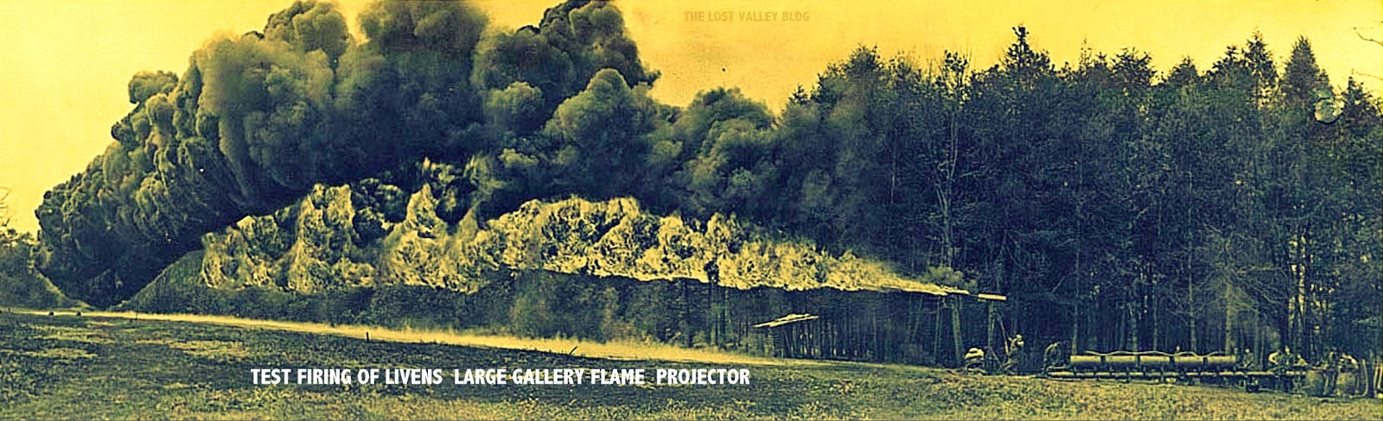

**Livens Stationary Flame Projector**

This item is new, and we have stock priced to sell. It's huge and can't be moved, but you can lead your assault with a gigantic wall of flame scare the enemy out of their defenses with the threat of being burned alive (think of Joan of Arc) don't pass up on this opportunity!

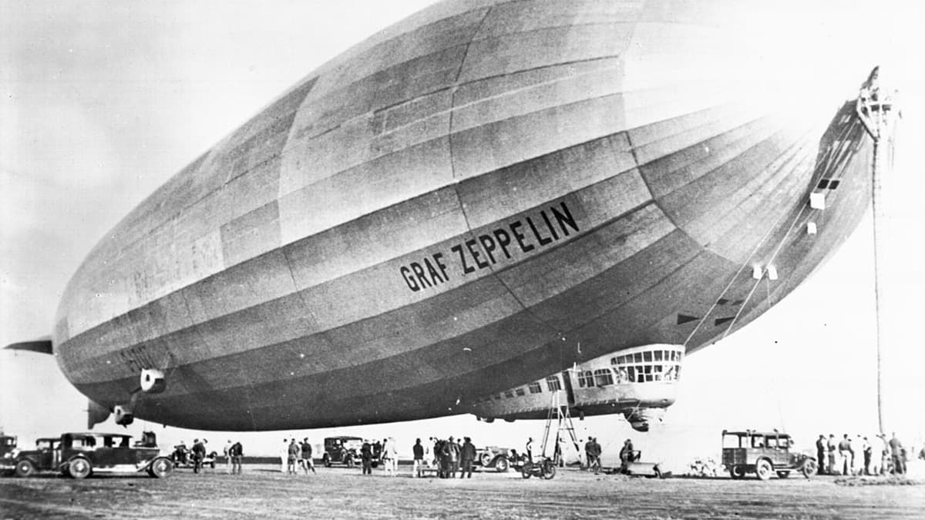

**Zeppelins**

This beast of the air can travel continuously for 24 hours. That means any city is ripe for terror bombing. Make the citizens of your enemies beg to get out of the war after unloading hundreds of bombs. Distance is no problem, and we guarantee they can't be brought down by anti-aircraft fire or your money back !

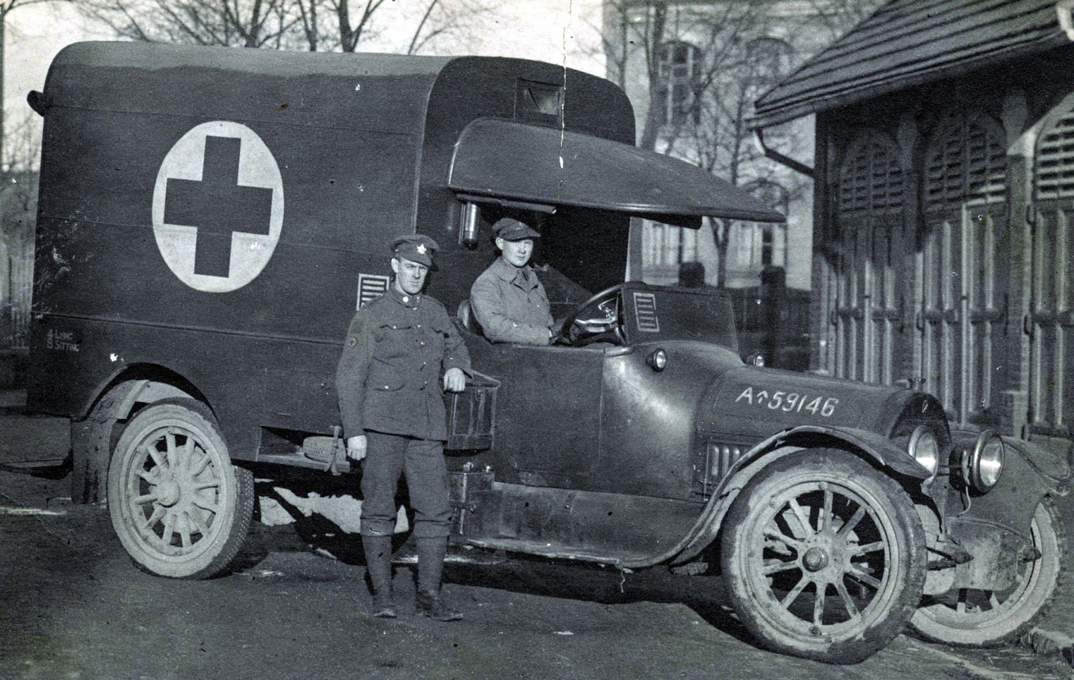

**Ambulance**

The automobile has arrived and guess what…. it has been retrofitted into a large wagon that can quickly ship your wounded troops back to the hospital where they can be fixed up and put back on the battlefield to kill your enemy once again. No longer do you need manpower or horsepower to do this arduous task.

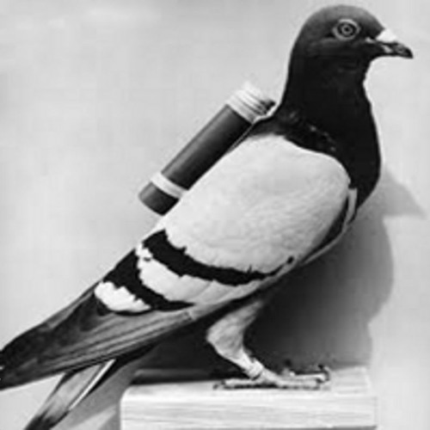

**Carrier Pigeons**

Don't trust wireless communication. Lines can be cut and sending a man to deliver messages would take forever. These birds can be trained to deliver vital information to headquarters just in time to stop an enemy threat. Buy now and will include enough feed to last a year. But let's be serious…. with this purchase, the war will be over in a month !

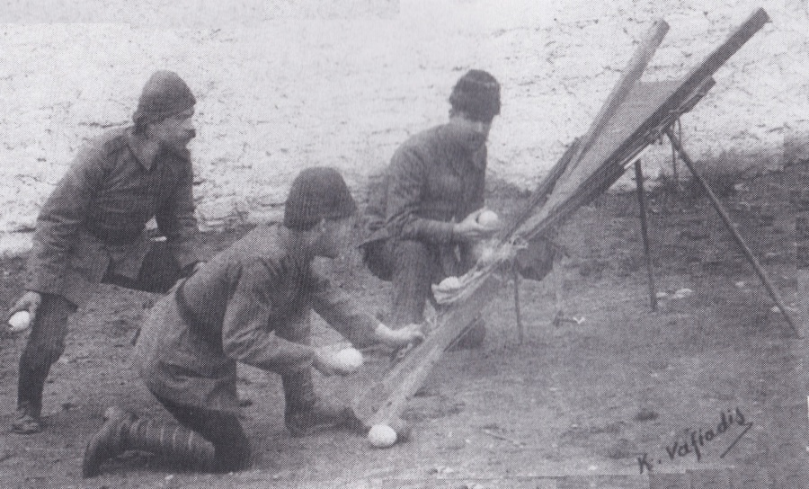

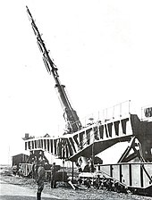

**Paris Gun**

You've seen artillery, but nothing like this monstrosity! This huge gun is so huge that it can only be used on a railroad track almost the length of a hockey rink! Imagine the blast crater it would leave. Your enemy will surrender just looking at it!

**Grenade Catapult**

Why try sneaking up on your enemy with grenades, when you can launch them from yards away with this ingenious catapult? your enemy will think it's raining eggs.