PREDICTION SIDE Name:
Date:

Quest: Your adventure with the French Revolution unit begins with a prediction exercise. Prediction, and Activating prior knowledge are two of the most powerful tools to assist with student learning.
*First, in the small box on the right with the hashtag, try to determine the year of the events. The time period is from 1789-1799. Put in a guess.
*Second, please write in a sentence or two what you think is going on. All of the pictures are connected with our unit of study. In essence, they will frame our historical journey.

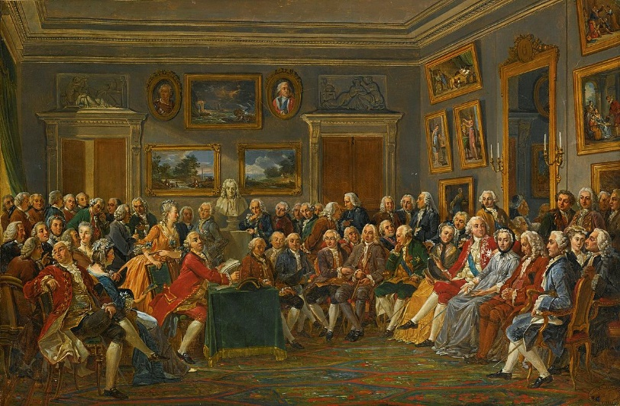

# WHAT’S GOING ON?

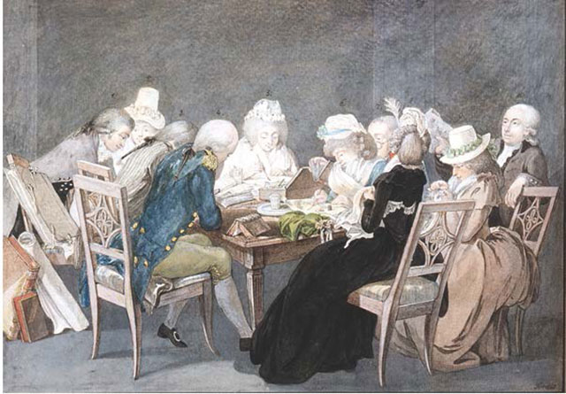

# WHAT’S GOING ON?

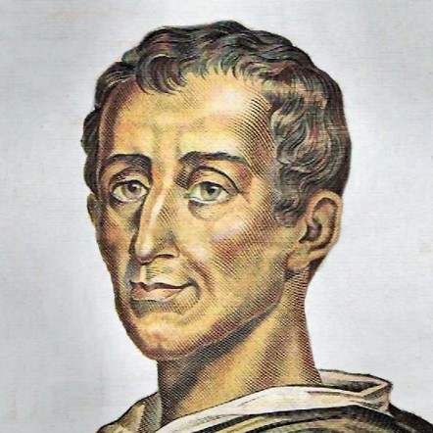

# WHAT’S GOING ON?

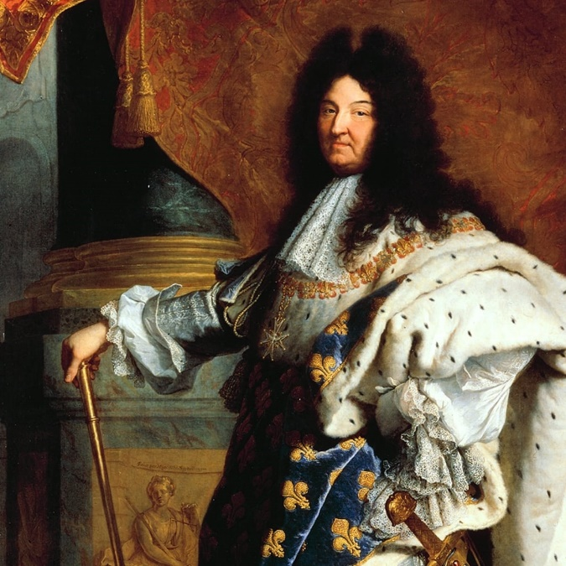

# WHAT’S GOING ON?

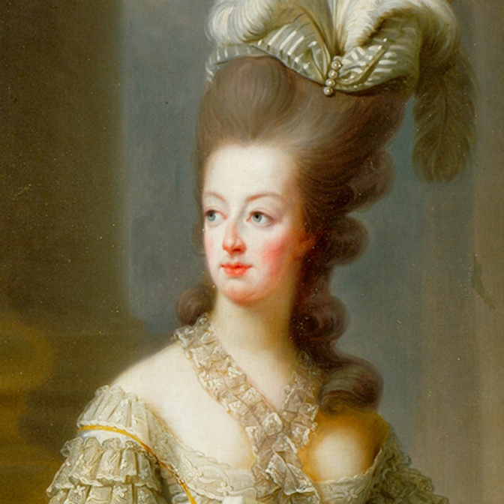
# WHAT’S GOING ON?

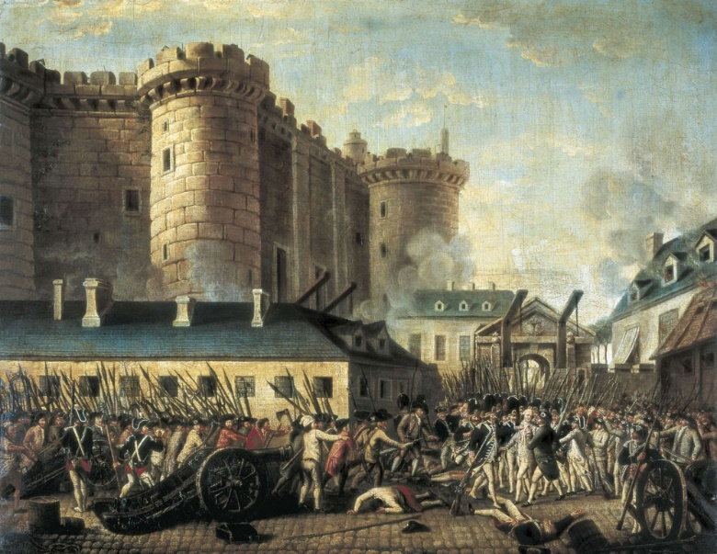

# WHAT’S GOING ON?

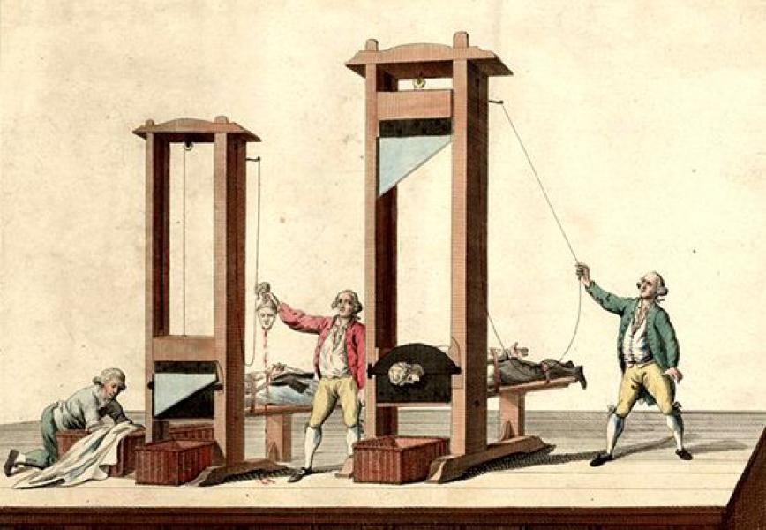

# WHAT’S GOING ON?

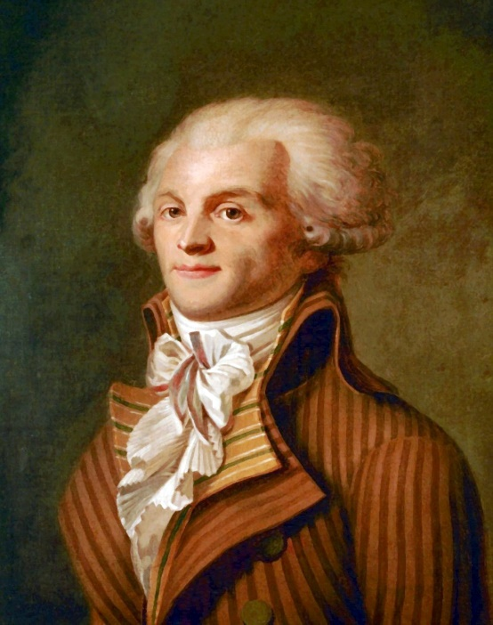

# WHAT’S GOING ON?

PREDICTION SIDE Name:
ANSWER KEY
Date:

Quest: Your adventure with the French Revolution unit begins with a prediction exercise. Prediction, and Activating prior knowledge are two of the most powerful tools to assist with student learning.
*First, in the small box on the right with the hashtag, try to determine the year of the events. The time period is from 1789-1799. Put in a guess.
*Second, please write in a sentence or two what you think is going on. All of the pictures are connected with our unit of study. In essence, they will frame our historical journey.

#1775 WHAT’S GOING ON?

A gathering of philosophes to discuss the newest ideas about society, politics, history and solutions to social problems

# WHAT’S GOING ON?
Wealthy and educated women held salons in their homes where philosophes can explore more ideas about society, government, religion.

# WHAT’S GOING ON?

Famous French Philosophe with an international reputation. He was a wealthy noble and believed in an ideal government would allow the ruler and elected officials to hold separate power.

Louis the XIV (14th) – King of France
# WHAT’S GOING ON?

# WHAT’S GOING ON?

Marie Antoinette married to the king – who was not very well liked by the French people.

# WHAT’S GOING ON?

The Bastille was a prison in Paris that was attacked by an angry mob.

# WHAT’S GOING ON?

The guillotine was used to chop off the heads of individuals who were sentenced to death

# WHAT’S GOING ON?

Robespierre was an influential figure during the revolution as he campaigned for universal manhood suffrage and the abolition of slavery, celibacy for the clergy.

