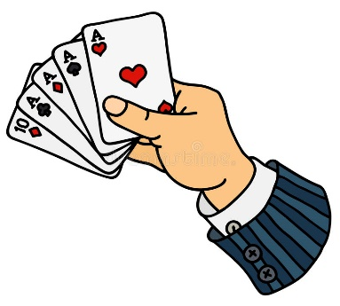
Name: ______________________ Receiver #: _____________
GPS POKER
With your partner you are responsible for hiding three numbered tennis balls and marking the coordinates in your GPS unit.

You and your partner will be responsible for finding ATLEAST five tennis balls that other groups have hidden. Each tennis ball has a number on it, each number corresponds with a playing card. You will not know what each number corresponds to which card until all the rounds we play are over. Students will then look at what numbers they have and what cards they correspond to and build a Poker Hand. The group with the highest poker hand WINS!
Round 1
Waypoint #______ Waypoint #_______ Waypoint #_______ Waypoint # _______ Waypoint #______
Hidden ball # ______ Hidden ball # ______ Hidden ball # _____ Hidden ball # _______ Hidden ball #
Card # ___________ Card # _______ Card # ________ Card # __________ Card # _________
POKER HAND: ___________________________________
Round 2
Waypoint #______ Waypoint #_______ Waypoint #_______ Waypoint # _______ Waypoint #______
Hidden ball # ______ Hidden ball # ______ Hidden ball # _____ Hidden ball # _______ Hidden ball #
Card # ___________ Card # _______ Card # ________ Card # __________ Card # _________
POKER HAND: ___________________________________
Round 3
Waypoint #______ Waypoint #_______ Waypoint #_______ Waypoint # _______ Waypoint #______
Hidden ball # ______ Hidden ball # ______ Hidden ball # _____ Hidden ball # _______ Hidden ball #
Card # ___________ Card # _______ Card # ________ Card # __________ Card # _________
POKER HAND: ___________________________________
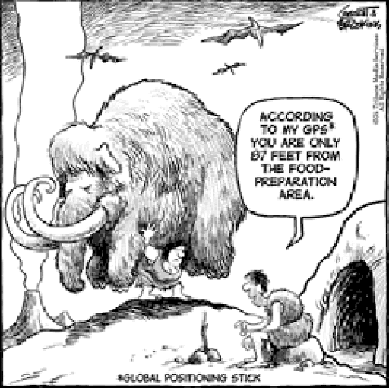
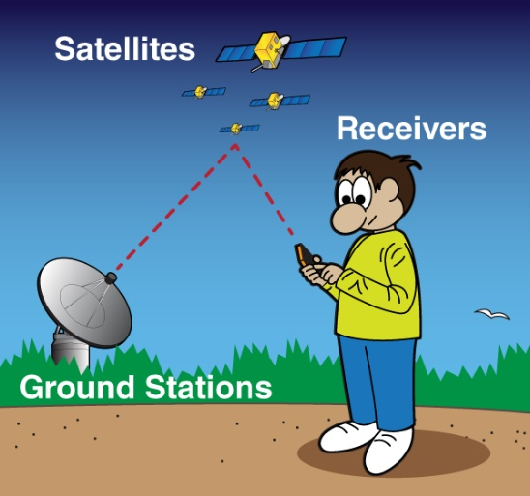

When creating your Poker Hand check out this diagram to see if you have one of these top ranked Poker Hands!

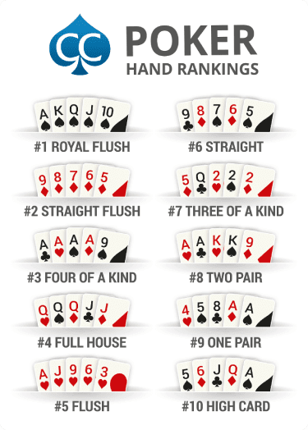

- 8
CARD CONVERSIONS
- QUEEN
- 9
- 3
- 8
- KING
- 6
- 4
- QUEEN
- JACK
- 5
- QUEEN
- ACE
- 9
- 4
- JACK
- 5
- 2
- 9
- 6
- 3
- 5
- KING
- 6
- 7
- 2
- 7
- 2
- 6

- KING
- 4
- 2
- JACK
- 10
- 7
- 3
- 3
- QUEEN
- 10
- 10
- 5
- 8
- 10
- KING
- JACK
- 8
- 4
- ACE
- ACE
- ACE
- 8
- 7

