Social, Political, Economic and Military Factors
Instagram Project

- In your group or pair decide on a factor from your web that your group could reenact and capture a picture
- As soon as you have your perfect picture, send it to s-bfleming@sd67.bc.ca so it can be printed
- Write a school appropriate caption that corresponds to your picture on your Instagram page
- Write at least 5 school appropriate hashtags that also correspond to your picture 1 hashtag must be a factor ex) #social #economic #military #political
- Make a clever Instagram handle as if you were napoleon
- Write your group names on the back of the project
- On the back of the assignment or on a separate piece of paper I want you to highlight 5 key pieces of information you have learned about Napoleon thus far and ask a question about him or the Napoleon unit.
- If you are stuck, look at this example...Note: You cannot steal the mustang thing now, it has been done.

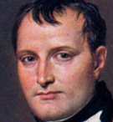
@NapoleonDynamite
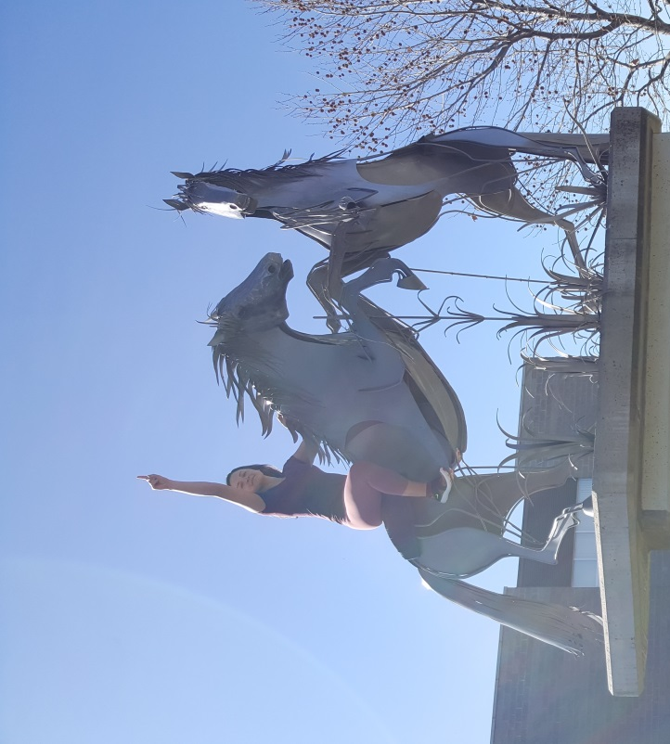
@Hitler @DonaldTrump @MadiSkillz
About to conquer the Alps on my strong and trusty stallion #social #fakenews #propaganda #donkey #naturewalk

