**Name _________________ Date __________________**

Napoleon’s Impact on Europe

Napoleon developed a strong military that was France’s _________ and _________. His army was well paid, well fed, well trained and ______________________. He gave his soldiers fancy uniforms awards and traditions.

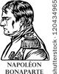

Napoleon promoted his generals ______________ the ranks, which did not happen in many European countries. He was one with the army; He ate with his army and looked after their welfare.

He called them his ________________________ and saw them as WINNERS! This helped them win even more and created a deeper sense of _________________.

**From ________ to ____________, Napoleon successfully battled most of Europe and created an _________________.**

* France **________________________** the ___________________, Belgium, and parts of Italy and Germany.
* Napoleon cut _____________________ territory in half and abolished the _____________________________________________________.
* He placed his own ___________________________ on some European thrones.

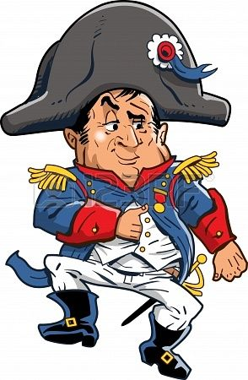Napoleon’s greatest victory was at the Battle of _____________________________. Or also known as The Battle __________________________________________ because it involved Napoleon, Czar Alexander I of Russia and Emperor Francis II of the Holy Roman Empire. Austerlitz was an important battle because it guarded the road to the capital city of ____________, Austria. The area had a large hill called Pratzen heights and had frequently ___________ days which Napoleon would capitalize using when attacking Austerlitz.

**Tactical Positioning!**

Napoleon placed his best soldiers on top of ________________________ as bait!

He figured this would draw the Austro-Russian armies’ attention to attack. He was __________!

When attacking, the French soldiers retreated down the hill, as the enemy followed and ended up in a section of _____________. Napoleons reinforcements who had been hiding in the fog ‘arrived’ at the same time as the retreating French troops who then turned to fight their enemy!

The battle was won because Napoleon had used his knowledge of the land to set a _________ and _____________ his enemies.

**________________________was the only major European power to remain outside of Napoleon’s empire.**

**__________________________­­­­** was Napoleons greatest enemy because they were both so big and powerful nations, with allies and colonies around the globe. Their conflict affected people ___________________. The _______________________ s­­mashed the French fleet in the Battle of Trafalgar in 1805, ending Napoleon’s plans to invade Britain. The British were under the command of Admiral ______________ _________________.

* Napoleon then imposed the **______________________ __________________** to close European ports to British goods. The blockades created some hardships but Britain was able to maintain its trade routes in _______________& the ____________________.

What was the **Continental System**?

**The Peninsular War**: ______________________ &________________________

Many Europeans who had welcomed the ideas of the French Revolution saw Napoleon and his army as **___________________________.**

* In Spain, people resisted reforms that undermined the ____________& the ___________________ Church.
* Napoleon placed his brother __________________ on the Spanish throne
* _____________________ in occupied countries created revolts and patriotic resistance through ___________________ _____________________.

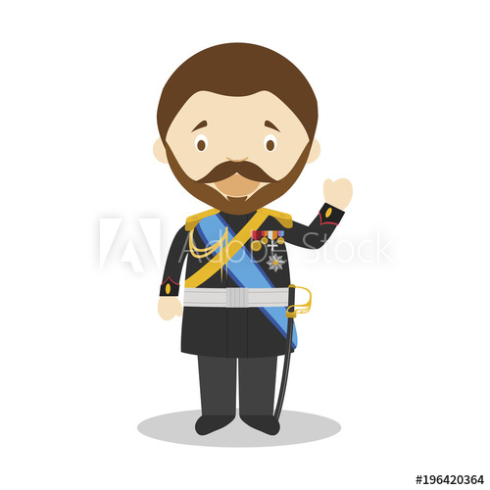 **RUSSIA**

Russia had become an ally of France and had agreed to stop trade with Britain at _____________! However, Czar Alexander did not trust Napoleon and changed his mind. Napoleon declared war on Russia, he believed he could defeat Russia _________________ if he drew them into a decisive battle.

Napoleon assembled the __________________________ Europe had seen with ________________ people. Napoleon won a few battles against the Russians and just when it looked like he would win, the Czar started to retreat and burn everything behind him. Which is called_______________________________________.

|  |
| --- |
| What is the purpose of this policy? |

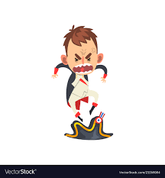Napoleon’s defeat in Russia was a HUGE setback to his plans. He tried to expand his empire by recruiting new soldiers and continued to fight against Russia, Britain, Austria, Sweden, Portugal and __________________.

**SMART GUY…..**

Paris was captured in 1814 and Napoleon’s own soldiers refused to march on the city….

Without the backing of the ________________, he was powerless. He abdicated (renounced) his role and was __________ to ______________. – Near Italy

Napoleon’s exile lasted only ______ months, he returned to France with 1000 soldiers and started to rebuild his forces. His new rule lasted only ______________ days.

He failed to make peace with Britain and fought the decisive battle of ______________________ which saw him suffer massive casualties.

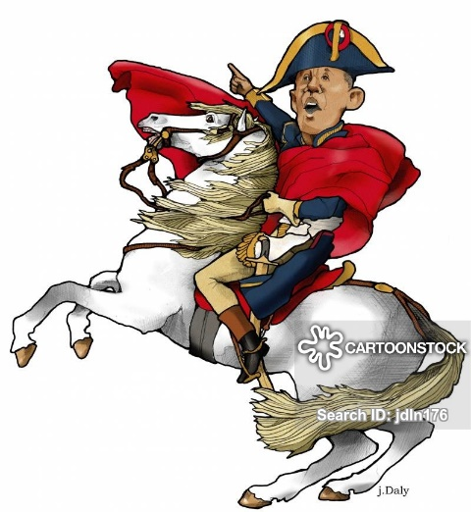He was officially defeated once and for all and taken to St. Helena an island in the South Atlantic where he died in _____.

