PREDICTION SIDE Name:
Date:

Quest: Your adventure with the American Revolution unit begins with a prediction exercise. Prediction, and Activating prior knowledge are two of the most powerful tools to assist with student learning.
*First, in the small box on the right with the hashtag, try to determine the year of the events. The time period is from 1765-1783. Put in a guess.
*Second, please write in a sentence or two what you think is going on. All of the pictures are connected with our unit of study. In essence, they will frame our historical journey.
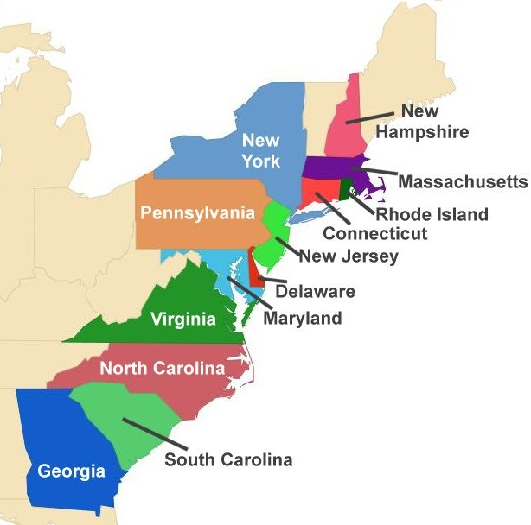

# WHAT’S GOING ON?

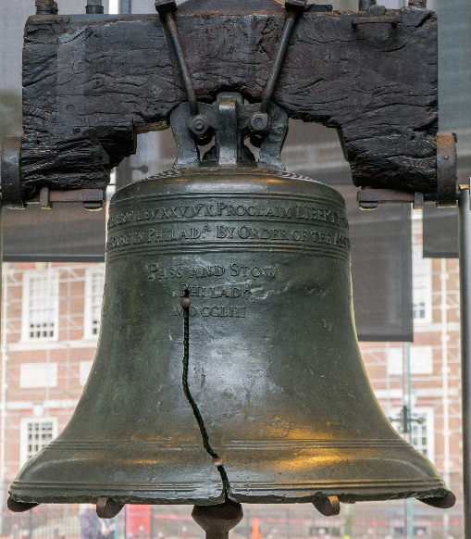

# WHAT’S GOING ON?

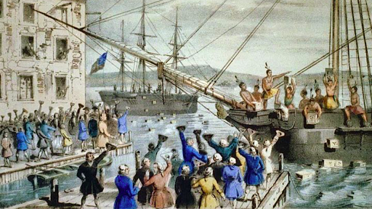
# WHAT’S GOING ON?

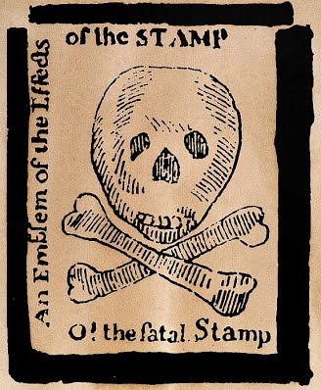

# WHAT’S GOING ON?

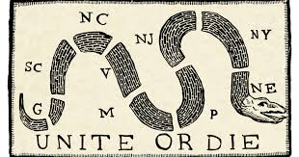
# WHAT’S GOING ON?

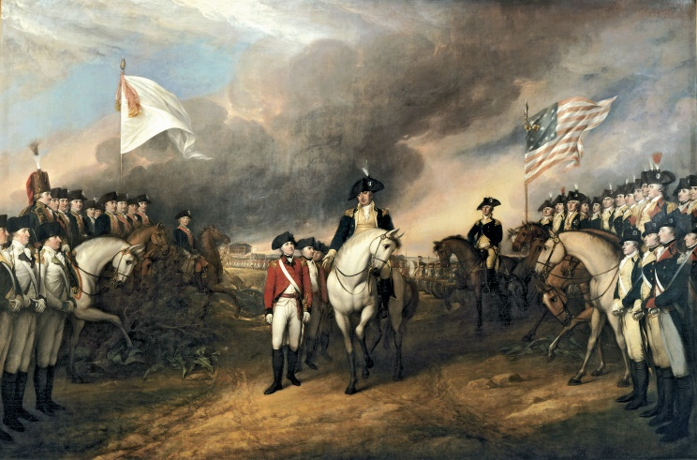
# WHAT’S GOING ON?

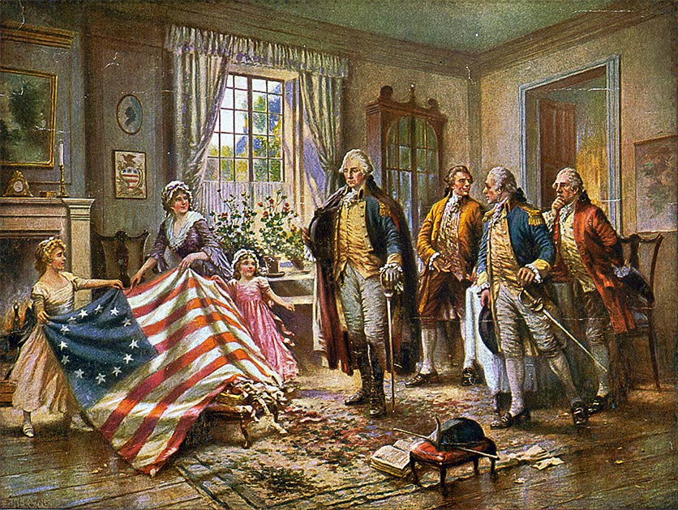

# WHAT’S GOING ON?

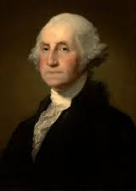
# WHAT’S GOING ON?

ANSWER SIDE Name:
Date

*First, in the small box on the right with the hashtag write the approximate year of the events. The time period is from 1765-1783.
*Second, please write in a sentence or two what you have learned is going on. Be sure to check back with your initial guess to see how close you were. In essence, these pics framed our historical journey.

# WHAT’S GOING ON?

13 colonies, were British on the Atlantic Coast & founded in the 17th & 18Th centuries and declared independence in 1776 to form the United States of America

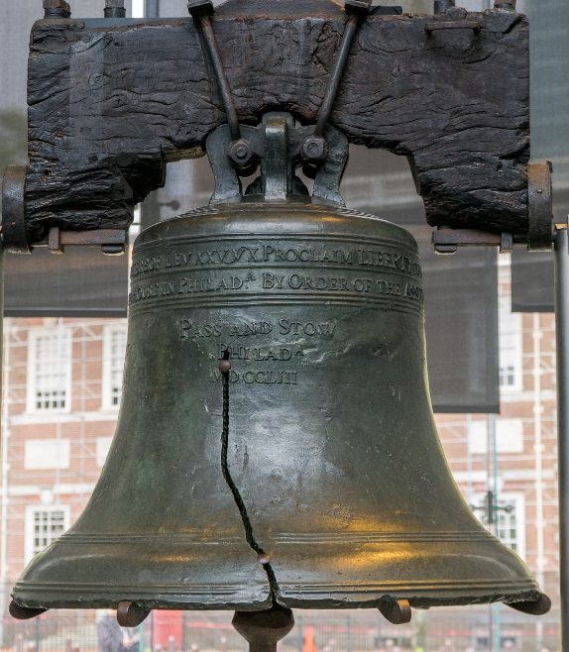

#1776 WHAT’S GOING ON?

Made in 1752, the liberty bell was in Pennsylvania and is said to of been rung when the Declaration of independence was announced in 1776

#1773 WHAT’S GOING ON?

116 people, some Sons of Liberty dressed as Mohawks. Boarded British ships docked in Boston. Destroying a fortune of Tea by dumping it into the harbor.

# 1765 WHAT’S GOING ON?

Fee for services, stamp had to be bought and put-on items that were bought and sold. Stamp act affected everyone, and American’s were enraged.

# WHAT’S GOING ON?

Political cartoon by Benjamin Franklin, American Inventor, Author & Politician. Saying the colonies need to unite together to win this war if you don’t you will have war upon yourself

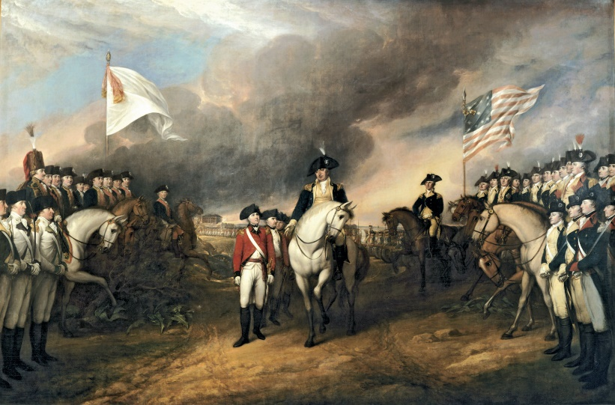
Oil canvas painting of the Surrender of Lord Cornwallis at Yorkton Virginia, October 19, 1781
#1781 WHAT’S GOING ON?
The women of 1776 “Molly Pitcher” the heroine of Monmouth. Women were hoping for societal change when the US was liberated. This is a painting of a woman sewing the flag for their independent country.
George Washington was one of the founding fathers of the United States and served as the first president. He led patriot forces to victory in the nations war to independence.
#1789 WHAT’S GOING ON?
#1776 WHAT’S GOING ON?

