Propaganda Poster / Film Assignment
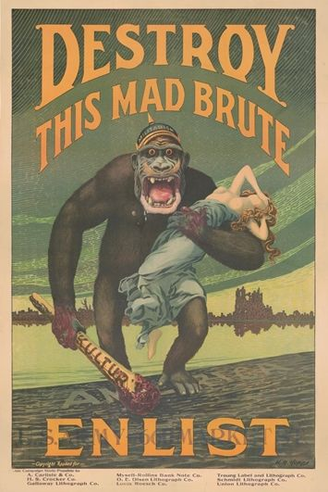
1. Define propaganda: Information, usually produced by governments, presented in such a way as to inspire and spread particular beliefs or opinions.
2. View the following YouTube videos and URLS
A. How To: Make Your Own Propaganda Poster - YouTube
B. Analysing WWI Propaganda Posters - YouTube
C. First World War Recruitment Posters - YouTube
D. The Great War: Propaganda Posters - YouTube
Assignment:
Goal: convince someone to enlist in the war effort
Role: working for the propaganda minister
Audience: able bodied men and women to help in the war effort
Situation: the numbers for enlistment are down, the propaganda minister needs your help to boost those numbers and help the allies win the war
Product: A poster or film
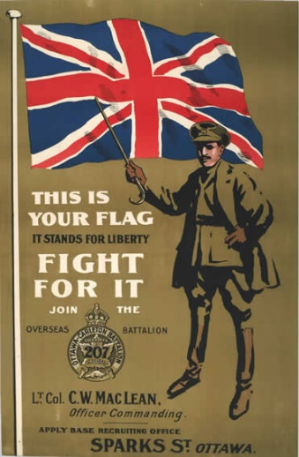
Standard/Expectation: colorful, eye catching, convincing to the reader, drawing on their emotions
Instructions: In partners you will create a World War 1 themed propaganda poster. The poster or film should be eye catching so that it would catch a person’s eye walking down the street. Create a rough sketch or design to be evaluated prior to your creation, to make sure it is on the right track and appropriate for school.
You may use magazine clippings along with your drawn images to attract the attention of your audience. Your poster should be colored and targeted towards a specific audience during this time period. Remember to have a clear message and all aspects of your poster should contribute to that message.
The guiding questions on the back page will help you get started with your design.
Supplies needed:
- Scissors, glue, pencil/pencil crayons, sharpy
- Smartphone and internet access (for filming)

Guiding Questions:
1. What topic will your poster be about?

2. Describe the poster you sketched in your own words.

3. What is this poster trying to get you to do?

4. How would this poster support the war efforts?

5. What historical facts are covered in this poster? What historical knowledge would the viewer need to fully understand your poster? Explain this part as thoroughly as possible.

Communicating
Communicate information and ideas effectively using an appropriate style for the audience and purpose
Structure information and ideas in a way that is appropriate to the specified format and course material
Achievement Level | Details
0 | Project not submitted and/or presentation not given on project
Emerging | Project is minimally convincing for the reader and does not stand out to draw people’s attention. Information is lacking clarity and effort was minimal.
Developing | Project is mostly effective in making people question how they can help the war effort and draws most people’s attention towards it. The message is straight forward for viewers to understand.
Proficient | Project is effective and convincing as to why people should volunteer to help the war effort. All information is clear and draws the reader’s attention.
Extending | Project is extremely effective and convincing for all readers with bright colour’s and clear information.

Creative Thinking
Visual representation relates to course concepts, issues, and models the information learned.
Synthesize course information to create a meaningful project for the time period.
Achievement Level | Additional Details
0 | No evidence of critical thinking of the course material
Emerging | Project is not creative and mimics one that was shown as an example, project was minimally researched to expand one’s knowledge for an effective and meaningful project.
Developing | Project is creative with some research done to expand one’s knowledge for an effective and meaningful project.
Proficient | Project is impactful and has been researched to show one’s knowledge of the course material.
Extending | The project is extremely impactful with colour and creativity that shows one’s knowledge of the course material.

Citing using APA formatting: Citation Machine®: Format & Generate - APA, MLA, & Chicago
You may use the citation machine URL above; however, it is more beneficial for you to learn how to cite on your own. Below is an example of how a citation should look when it is completed.
Ex). Authors last name (surname), Initial(s). (Date published). Title of the source. Location of publisher: publisher. Retrieved from URL
Ex). Fleming, J. (January 7, 2021). Propaganda Poster/Film Assignment. Penticton BC: Princess Margaret Secondary School.

