Name .

Britain North American Experience
, and fought over territory in the Americas to establish colonies to help their empires grow and flourish.
European countries pushed to expand into the Americas for many reasons; one of Britain’s reasons was that it could provide many resources such as.
- .
- .
- .
Britain started promoting the colonies to , and people to have a restart at a better life in the new world. It was a way for Britain to build the population of the colonies quicker with working people wanting a fresh start as well as cleaning up the streets of Britain.
Starting fresh in a new world is tough, .
. Many struggled to establish themselves, the mortality rate of new settlers was high. People and as well as to death in the winter from the harsher weather than they experienced in Britain.
Negotiation
Some colonists negotiated tribes, which also brought new for indigenous people such as:
- .
- .
- .
13 Colonies
England established 13 colonies along the eastern coast of North America from Maine to Georgia, each colony was at different times and for any different reasons. Each colony had its own & .
Colonies were founded for many reasons, was founded for reasons. While others such as and were for religious or refuge reasons.
Independent
Each colony was independently operated with little in common and many of the leaders had visited the other colonies. Each colony could thrive on their own . However, the colonies were to provide their resources to Britain which were used to manufacture goods that Britain would then be sold the colonies. The colonies by law were to disrupt the flow of business for Britain, they were prevented from manufacturing economically.

What problems do you think this created in the colonies? How did people feel about this law?
(answer on the next three lines, the following three will be for the answer given in class)
.
.
.
In class answer
.
.
.
The Mistake
Britain made one Big mistake, they the only reason the colonies needed British soldiers for protection. They captured . Who for fun fact would later help the colonies achieve independence from Britain and become the United States of America.

Why do you think the American independence was so revolutionary?
.
.
.
.

Britain’s Society
Society in Britain was ruled by Strict monarchs in this time period (18th century). The wealthy were the only one who could or
Which meant they only looked out for themselves to stay rich and get richer, making it hard for anyone to move up in social status.
Britain was a military empire who defeated and in battle for colonies and territories all over. A battle with the colonies should be no problem for them, however, a battle for was something no one had much experience with.
Britain was dumbfounded they would think the empire owed them anything, the purpose was to provide for the and Britain gave those families a fresh start by moving.

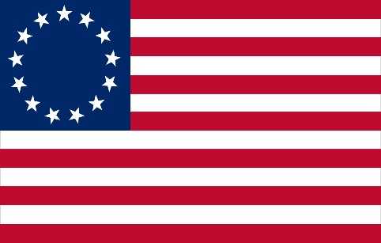

Definitions
Sovereign –

Independent –

Sugar Islands –

Land Speculator –

Smuggler –

Protest –

Repeal –

Sons of Liberty –

Patriot –

Intolerable Acts –

Boycott –

Privateer –

Loyalists –

Abolitionist –

Ambassador –

Veto –

