, and fought over territory in the Americas to establish colonies to help their empires grow and flourish.
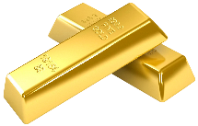
European countries pushed to expand into the Americas for many reasons; one of Britain’s reasons was that it could provide many resources such as.
- .
- .
- .
Britain started promoting the colonies to , and people to have a refresh at a better life in the new world. It was a way for Britain to build the population of the colonies quicker with working people wanting a fresh start as well as cleaning up the streets of Britain.
Starting fresh in a new world is tough, .
. Many struggled to establish themselves, the mortality rate of new settlers was high. People and as well as to death in the winter from the harsher weather than they experienced in Britain.
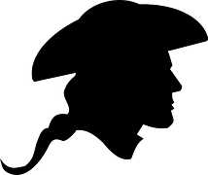
Some colonists negotiated tribes, which also brought new for indigenous people such as , and .

13 Colonies
England established 13 colonies along the eastern coast of North America from Maine to Georgia, each colony was at different times and for any different reasons. Each colony had its own government & .
Colonies were founded for many reasons, was founded for reasons. While others such as Massachusetts and were for religious or refuge reasons.

Each colony was independently operated with little in common and many of the leaders had
visited the other colonies. Each colony could thrive on their own &
. However, the colonies were to provide their resources to Britain which were used to manufacture goods that Britain would then .
The colonies by law were to disrupt the flow of business for Britain, they were prevented from manufacturing economically.
This Photo by Unknown Author is licensed under CC BY-NC
What problems do you think this created in the colonies? How did people feel about this law?
(answer on the next three lines, the following three will be for the answer given in class)
.
.
.
In class answer
.
.
.

Britain made one Big mistake, they the only reason the colonies needed British soldiers for protection. They captured . Who for fun fact would later help the colonies achieve independence from Britain and become the United States of America.

Why do you think the American independence was so revolutionary?
.
.
.
.

Society in Britain was ruled by Strict monarchs in this time period (18th century). The wealthy were the only one who could or . Which meant they only looked out for themselves to stay rich and get richer, making it hard for anyone to move up in social status.
Britain was a military empire who defeated and in battle for colonies and territories all over. A battle with the colonies should be no problem for them, however, a battle for was something no one had much experience with.
Britain was dumbfounded they would think the empire owed them anything, the purpose was to provide for the and Britain gave those families a fresh start by moving.
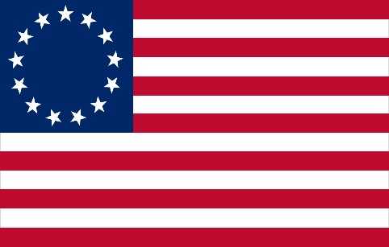

Definitions
Sovereign –
Independent –
Sugar Islands –
Land Speculator –
Smuggler –
Protest –
Repeal –
Sons of Liberty –
Patriot –
Intolerable Acts –
Boycott –
Privateer –
Loyalists –
Abolitionist –
Ambassador –
Veto –

Answer key

England, France and Spain fought over territory in the Americas to establish colonies to help their empires grow and flourish.
European countries pushed to expand into the Americas for many reasons; one of Britain’s reasons was that it could provide many resources such as.
- Furs .
- Timber .
- Gold .
Britain started promoting the colonies to poor , troubled and landless people to have a refresh at a better life in the new world. It was a way for Britain to build the population of the colonies quicker with working people wanting a fresh start as well as cleaning up the streets of Britain.
Starting fresh in a new world is tough, they did not know the climate or the fertility of the area. Many struggled to establish themselves, the mortality rate of new settlers was high. People starved and froze to death in the winter from the harsher weather than they experienced in Britain.
Some colonists negotiated trade relationships with nearby indigenous tribes, which also brought new for indigenous people such as smallpox, measles and influenza .

13 Colonies
England established 13 colonies along the eastern coast of North America from Maine to Georgia, each colony was founded at different times and for many different reasons. Each colony had its own government & legislature .
Colonies were founded for many reasons; Virginia was founded for economic reasons. While others such as Massachusetts and Maryland were for religious or refuge reasons.

Each colony was independently operated with little in common and many of the leaders had
NEVER visited the other colonies. Each colony could thrive on their own economic goals &
needs . However, the colonies were to provide their resources to Britain which were used to manufacture goods that Britain would then sell back to the colonies.
The colonies by law were NOT allowed to disrupt the flow of business for Britain, they were prevented from manufacturing their own goods and develop economically.
This Photo by Unknown Author is licensed under CC BY-NC
What problems do you think this created in the colonies? How did people feel about this law?
(answer on the next three lines, the following three will be for the answer given in class)
.
.
.
In class answer
It made the colonies dependent on Britain, Britain controlled everything they did. In trade the colonies had use of the British army for support. .
Britain made one Big mistake; they eliminated the only reason the colonies needed British soldiers for protection. They captured New France, who for fun fact would later help the colonies achieve independence from Britain and become the United States of America.

Why do you think the American independence was so revolutionary?
.
.
.
.

Society in Britain was ruled by Strict monarchs in this time period (18th century). The wealthy were the only one who could vote or create laws . Which meant they only looked out for themselves to stay rich and get richer, making it hard for anyone to move up in social status.
Britain was a military empire who defeated France and Spain in battle for colonies and territories all over. A battle with the colonies should be no problem for them, however, a battle for was something no one had much experience with.
Britain was dumbfounded they would think the empire owed them anything, the colonies purpose was to provide for the empire and Britain gave those families a fresh start by moving.

Definitions

Sovereign – independent; having self-government

Independent – the state of being self-governing and not under the authority of another country

Sugar Islands – a term describing the islands of the West Indies (Caribbean) known for sugar can production; included Martinique, Jamaica, and Barbados

Land Speculator – a person who buys and sells land for a profit

Smuggler – someone who imports and exports goods illegally

Protest – a public demonstration of objection, often to a government policy

Repeal – to take back
Sons of Liberty – Revolutionary organization to advance the rights of European colonists to fight taxation by the British Government

Patriot – A person who devoted to the interests of his or her country

Intolerable Acts – acts passed by British parliament, considered by American colonists to violate their natural and constitutional rights

Boycott – refuse to buy goods from particular source

Privateer – a private ship or individual authorized by a government to attack foreign ships during wartime

Loyalists – residents of the Thirteen Colonies who remained loyal to Britain during the American Revolution

Abolitionist – someone working to end slavery

Ambassador – an official delegate of one nation to the government of another nation

Veto – to stop or reject a legislative enactment

