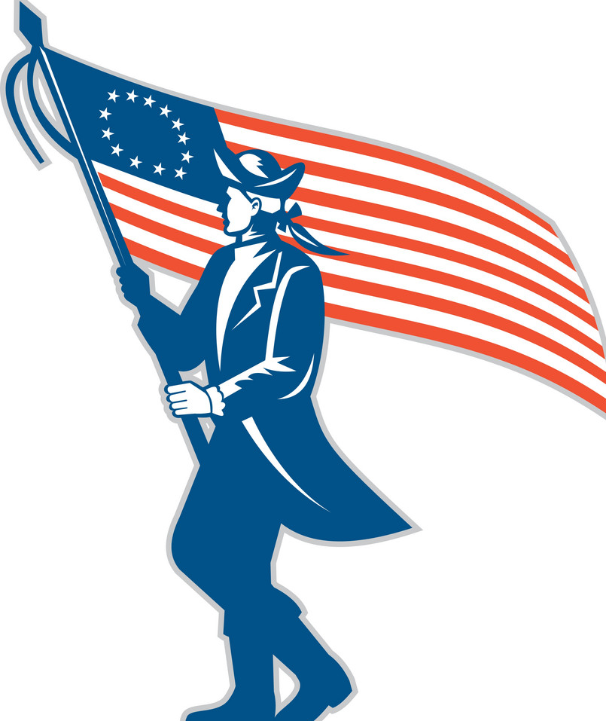
Socials 9 CLUES PAGE Group:
The Patriot cause is in dire need of your assistance, gathering intelligence on British soldiers in the area to locate their supplies. As a spy, find the location of their supplies. This work requires problem solving, creative and critical thinking skills.
Goal: Hunt for the answers to fill in the blanks on your Patriot scavenger hunt. You must read the writings fully and then answer. You will be instructed to start at a certain clue (#1-6) and then go through the clues until you have gathered all the intelligence we need. Check off the clues when done (on the left side).


1. British Intelligence: Up and down, up and down. Elevate your knowledge by gathering your notes in a very uplifting spot.
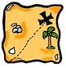
2. Rules/Dealing With problems: The bugle is music to my ears. Quit harping away and go here for the answers.

3. Prepare for battle: I would go see Jim. He will give you a slam dunk. Hopefully, you will net the answer, get start running.


4. Needs and Wants: asenwrs can be hrad to udenrtsnad. Fnid a stariawy on the nroth-esat sdie of teh sohcol and you wlil fnid the nxet set of cuels.

5. Your role is vital to the cause: If you want to know the answer to any questions, this place wood be a good spot to start… you might say it “would work” to look there…

6. We need a chemist for our cause: Explosives are truly what we need to make our presence known for this conflict.

WELL, DONE, CHAMPS! YOU’VE FINISHED THE HUNT. NOW PLEASE RETURN BACK TO CLASS WITH YOUR ANSWERS!

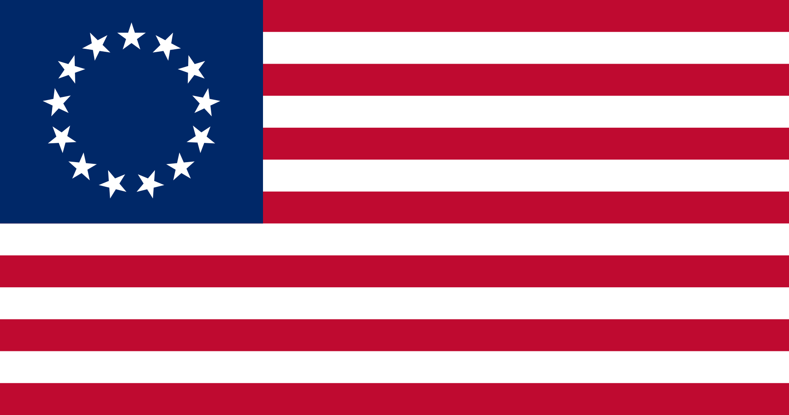
Socials 9 – Mr. Fleming Name:
NOTES ON The Causes of dissatisfaction in the colonies:
Overview: Britain spent a great deal of money on soldiers and supplies to protect the 13 colonies during the seven years war. Britain thought it was fair the 13 colonies should share the debt that accumulated. The British government tried to tax the American colonists to raise the money and it was met with resistance.
The Issue of Rights
-American colonists believed their rights were being ignored and as British subjects they were being trampled on by the British government.
Taxes by the British Government
Europe was ruled by the rich and Britain felt the America’s should have a role in paying back
part of the debt by evoking taxes on the colonies. Two main taxes were introduced.
1. The Sugar Act in 1764 - changed the taxation on sugar and its by products, such as molasses.
2. The Stamp Act in 1765 - a stamp needed to be purchased and placed on items that were bought and sold.
The stamps needed to be purchased for the following documents:
- Documents
- Deeds
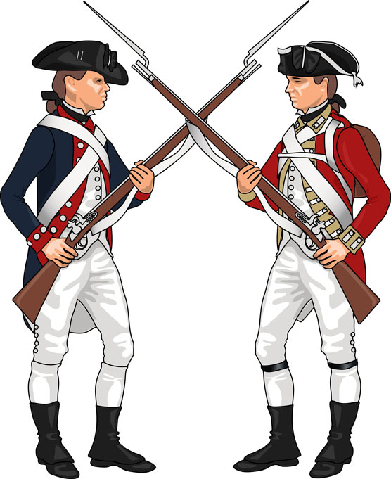
- Licenses
-Sugar act made smuggling harder from the west indies to the colonies as it put more pressure on the captain to keep a detailed log of their cargo and customs officials were given new powers.
-The stamp act affected everyone and enraged the Americans.
-Felt they were being taxed without their consent.
-Officials sent out to enforce the act and were often attacked
-Some were tar and feathered

- Few officials were brave enough to force people to use the stamps and everyone in Britain knew it was a disaster, the act was repealed in 1766.

New Tax in Town
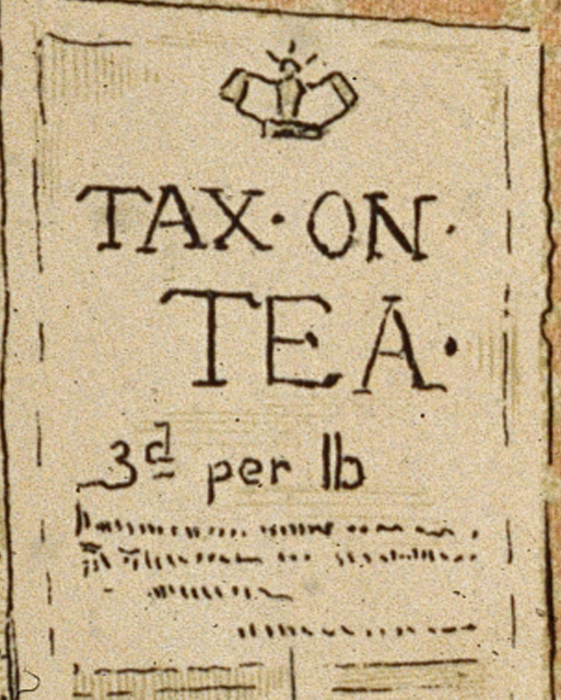
- A new tax was now introduced called the Townshend Acts. Which included duty on paper, paint, glass and tea. All were goods that had to be shipped in from outside the colonies.
- Some believed this act was only to show America that Britain still had power over them as this raised little money.
- The Americans once again protested and got the tax abolished, EXCEPT for the tax on tea.
- This was kept to support the British India Tea Company
- This did not sit well with Americans and the protesting grew, which forced Britain to post troops in the 13 colonies stationed in locals’ homes.
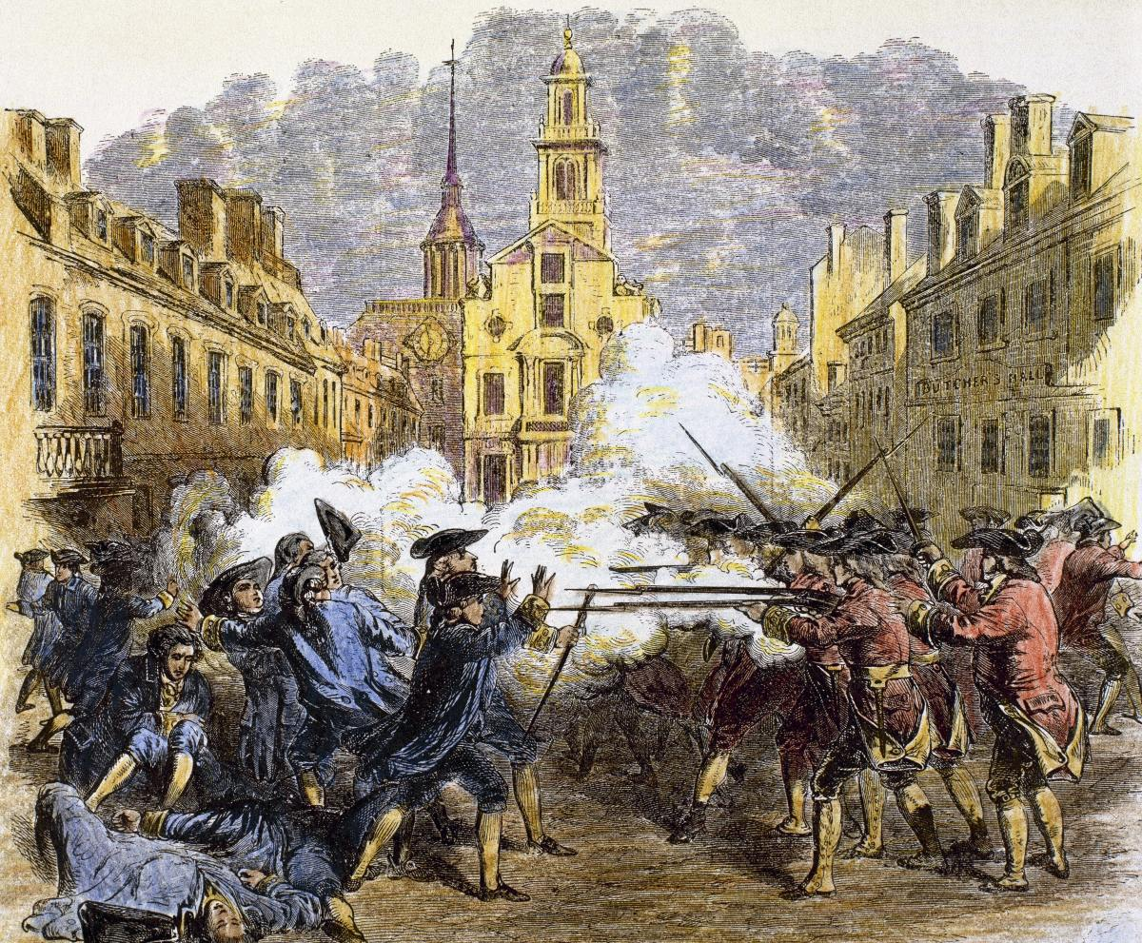
The Boston Massacre
-Nervous British soldiers misunderstood an order and opened fire on a crowd of protesters in Boston killing several people
-The “Boston Massacre” was quickly turned into anti British propaganda
The Sons of Liberty was a group of political activists dedicated to resist British taxes and trade restrictions and willing to resort to violence, burning buildings and harassing British tax officers.
-Their first act was the looting and burning of the British customs ship the Gaspee in 1772, the ship ran aground chasing an American ship and the Sons of Liberty rowed out to it, looted it, and burned it.
Boston Tea Party
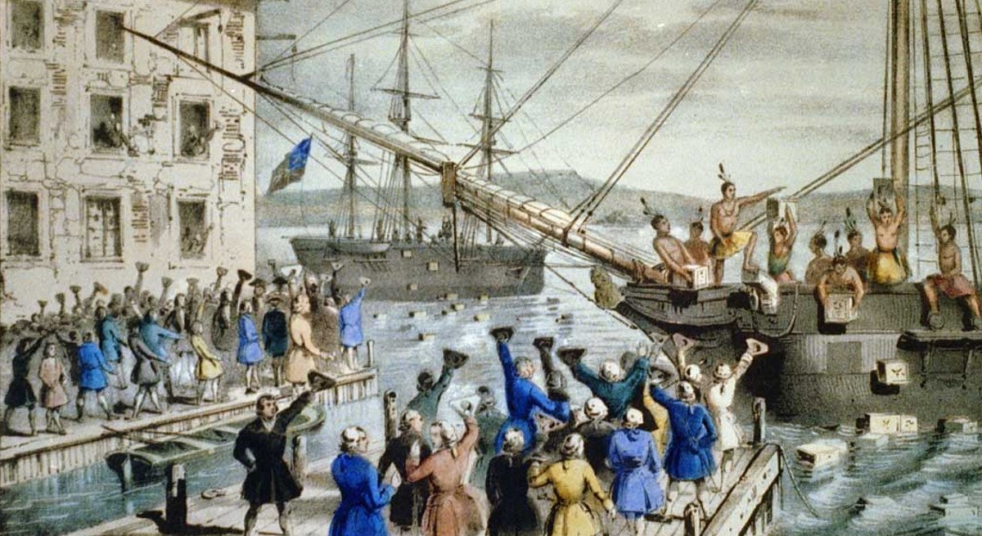
-116 people including the Sons of Liberty dressed as Mohawks boarded British ships docked in the Boston Harbour. They destroyed a fortunes worth of tea by throwing it into the harbour, which was in protest to the tea act which still protected the British India Tea Company.
-One of the most important and symbolic events leading to the American Revolution.

Intolerable Acts
-When news reached Parliament, they proposed a new act called the Intolerable Acts that was meant to punish Boston and assert British authority. Many viewed these acts a violation to their natural and constitutional rights and saw the acts as a threat of their freedom.
Massachusetts Government Act
All positions in the colony’s government are now appointed by the British. Town meetings can be held only once a year.
Boston Port Act
Closes the port of Boston until the India Tea Company is compensated for the destroyed tea

Increasing Protests

Quartering Act
Colonial governors may house soldiers in any unoccupied building. Colonists believe this includes private homes.
Administration of Justice Act
British officials accused of crimes can have their trials held in another colony or even Great Britain

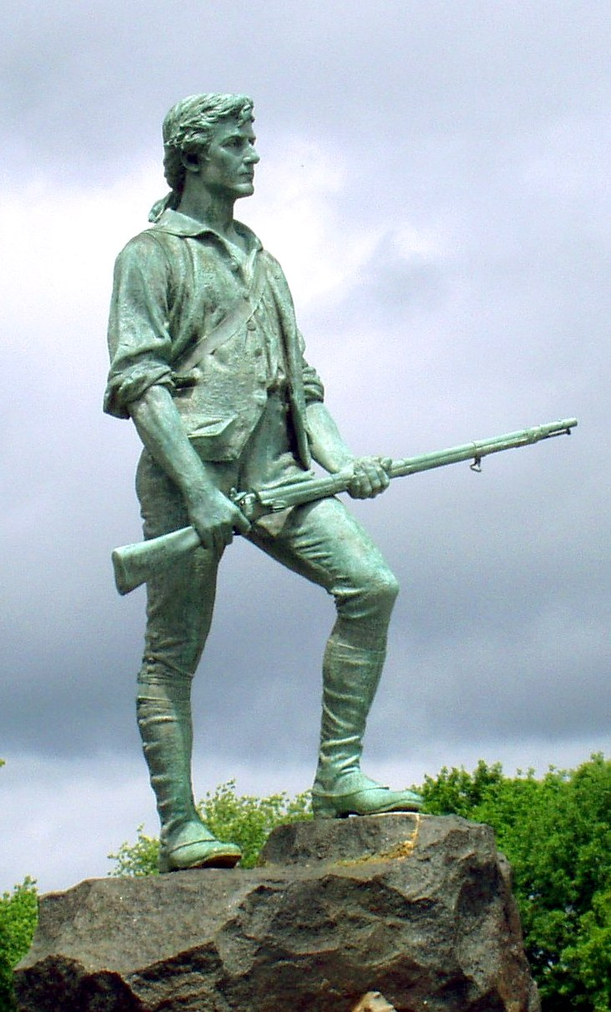
The First Continental Congress
The Quebec act of 74 gave Quebec land behind the 13 colonies, which outraged the Americans as they saw it as part of the Intolerable Acts to punish them. When it was really to keep Quebec happy and remain a British colony.
-12 out of the 13 colonies sent leaders to Philadelphia for the first continental congress, which began by defying the British government.
-Leaders demanded a boycott of goods from England and began cutting economic ties with the home country.
-The leaders of America found it difficult to organize an opposition to the British, each colony was separate and had its own legislature.
-There was no American identity, unlike today they saw themselves as where they lived, New yorker, Marylander etc...
The 13 colonies however were united by cause: to gain economic and political freedom from the distant colonial government.

Socials 9 – Mr. Fleming Name:
NOTES ON The Causes of dissatisfaction in the colonies:
Overview: Britain spent a great deal of money on soldiers and supplies to protect the 13 colonies during the seven years war. Britain thought it was fair the 13 colonies should share the debt that accumulated. The British government tried to tax the American colonists to raise the money and it was met with resistance.
The Issue of Rights
-American colonists believed their rights were being and as British subjects they were being on by the British government.
Taxes by the British Government
Europe was ruled by the rich and Britain felt the America’s should have a role in paying back
part of the debt by evoking taxes on the colonies. Two main taxes were introduced.
1. - changed the taxation on sugar and its by products, such as molasses.
2. - a stamp needed to be purchased and placed on items that were bought and sold.
The stamps needed to be purchased for the following documents:
- .
- .
- .
-Sugar act made smuggling harder from the west indies to the colonies as it put more pressure on the captain to keep a detailed log of their cargo and customs officials were given new powers.
-The everyone and the Americans.
-Felt they were being without their consent.
-Officials sent out to enforce the act and were often attacked
-Some .

- Few officials were to use the stamps and everyone in Britain knew it was a , the act was repealed in 1766.

New Tax in Town
- A new tax was now introduced called the . Which included duty on , paint, glass and . All were goods that had to be shipped in from the colonies.
- Some believed this act was only to show America that Britain over them as this raised money.
- The Americans once again protested and got the tax abolished, for the tax on tea.
- This was kept to support the British .
- This did not sit well with Americans and the protesting grew, which forced Britain to post troops in the 13 colonies stationed in locals’ homes.
The Boston Massacre
-Nervous British soldiers misunderstood an order and on a crowd of protesters in Boston killing several people
-The “ ” was quickly turned into anti British propaganda
The was a group of political activists dedicated to resist British taxes and trade restrictions and willing to resort to violence, and harassing British tax officers.
-Their first act was the looting and burning of the British customs ship the in 1772, the ship ran aground chasing an American ship and the Sons of Liberty rowed out to it, looted it, and burned it.
Boston Tea Party
-116 people including the Sons of Liberty dressed as boarded British ships docked in the Boston Harbour. They destroyed a fortunes worth of tea by throwing it into the harbour, which was in protest to the tea act which protected the British India Tea Company.
-One of the and symbolic events leading to the American Revolution.

Intolerable Acts
-When news reached Parliament, they proposed a new act called the that was meant . Many viewed these acts a violation to their natural and constitutional rights and saw the acts as a threat of their freedom.
Massachusetts Government Act
All positions in the colony’s government are now appointed by the Town meetings can be held only once a year.
Boston Port Act
Closes the port of Boston until the India Tea Company is for the destroyed tea

Increasing Protests

Quartering Act
Colonial governors may house soldiers in any unoccupied building. Colonists believe this includes private homes.
Administration of Justice Act
British officials accused of crimes can have their held in another colony or even Great Britain

The First Continental Congress
The Quebec act of 74 gave Quebec land behind the 13 colonies, which the Americans as they saw it as part of the Intolerable Acts to punish them. When it was really to keep Quebec happy and remain a British colony.
-12 out of the 13 colonies sent leaders to Philadelphia for the first , which began by defying the British government.
-Leaders demanded a boycott of goods from England and began cutting ties with the home country.
-The leaders of America found it to organize an opposition to the British, each colony was separate and had its own legislature.
-There was no American , unlike today they saw themselves as where they lived, New yorker, Marylander etc...
The 13 colonies however were united by cause: to and from the distant colonial government.

