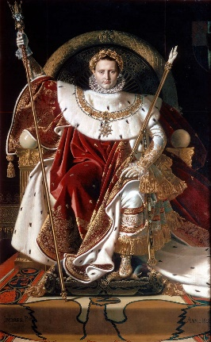
Individuals and Society Year 4 (Socials 9)
(Revolutions, European war, and North America 1750-1919)
Introduction: Social Studies 9 provides the knowledge and skills necessary for students to become responsible citizens of Canada and the world. This course examines historical events that contributed to Canada’s national identity and development as a democratic constitutional monarchy. We will explore how Canada was discovered and settled and the European events that contributed to the type of government and rights we enjoy. It also aims to help students explore the diverse geographical landscape of the country.
Skills and Processes: Students will develop the ability to:
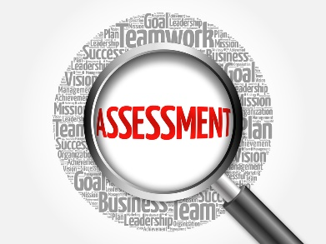
* Think critically. * Research from appropriate sources. * Assess the reliability of evidence. * Express appropriate responses to issues.
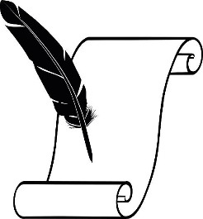
Assessment and Evaluation
-Conducted on an ongoing basis.
-Using the Proficiency Scale
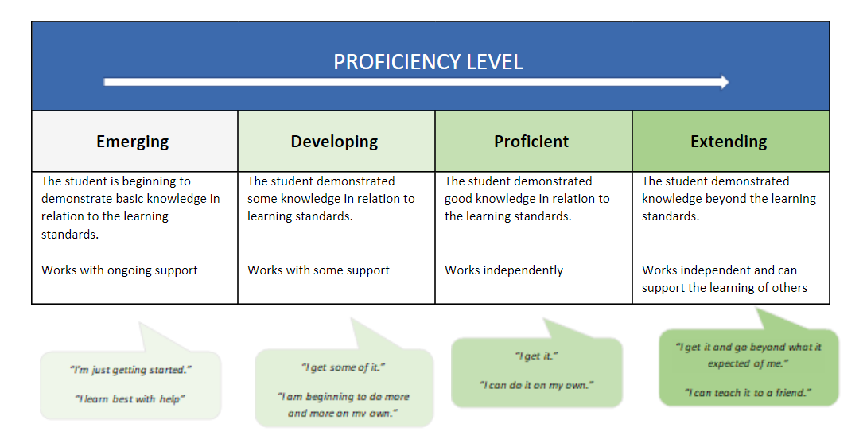
-Tests/Quizzes, Projects, Assignments, Essays, Seminars, Simulations!
Materials – Bring to EVERY class: Binder; Paper; Pencil/ Pen; Text.
Textbooks/Resources à Crossroads, Pearson School Atlas, newspapers, newscasts (provided) Materials needed (at times) à pen, pencil crayons, ruler.
Expectations
1. I will aspire to keep homework to a minimum. Most assignments will be done in class. In return, I expect that all students will make every effort to attend each class on time. Parents will be contacted when students have unexcused absences or excessive lates. If you must be absent from a class, it is your responsibility to pick up the assignments you missed, preferably before class.
2. Come to class on time, prepared and ready to work. Treat everyone with respect.
3. Catch up on missing assignments in a timely manner. Students with missing assignments will be asked to stay in at lunch or attend homework room. Use the website to keep caught up if you must miss class.
4. During class discussions leave all electronics in your bag. During independent work you may use your device to listen to music, but you cannot use your device during other class times.
CONTACT INFORMATION:
EMAIL: bfleming@sd67.bc.ca
WEBSITE: mrbfleming.weebly.com

Geography Unit: It will “Rock” your world!
“Sometimes I think war is God’s way of teaching us geography.” - Paul Rodriguez
“Geography is about maps, but Biography is about chaps” – Eric Bentley
A basic introduction to the geography of North America and to geographic terms.
Statement of Inquiry: Understanding our Time, place and space helps us understand our perspective and identity.
Unit 1 - Geography (P. 160-178) ~ “Latitude with Attitude”
In this active unit we will learn about the basics of physical geography such as latitude/longitude, mapping, weather, and the physical regions of Canada. We will finish the unit with a trip to Okanagan Lake to identify what we learned in on the real physical landscape of Penticton!
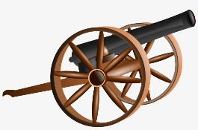
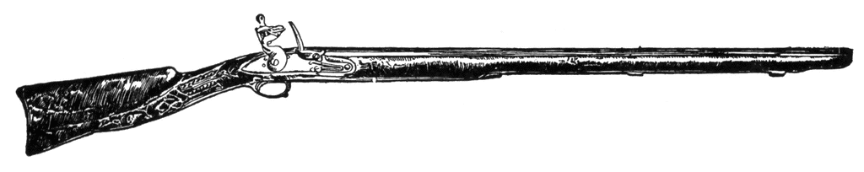
Heads Will Roll: Blood, Guts, Glory, Revolution and Battle!
Europe and North America 1750-1919
“Those who don't know history are destined to repeat it.” ~ Edmund Burke. The European History will familiarize students with the roots of modern democracy, colonialism, and warfare. Get ready for beheadings, little-man syndrome, the worst outcome of a snowball fight in history and boys burned alive in chimneys.
Statement of Inquiry: Revolutions can create change and are affected by people who believe that they have a lack of access to power and privilege.
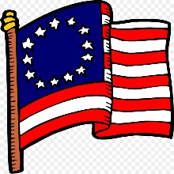
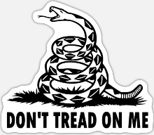
UNIT 2 - The American Revolution (P.157-178).
Have you ever wondered why Americans love guns? Or why they hate tea? We will learn about why the Americans violently overthrew their British dictator and have since (in their opinion) been the “defenders of freedom.” We will also study the movie The Patriot and decide if it accurately reflects history.
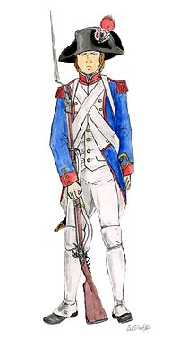
Unit 3 – French Revolution (P. 186-225)
Here we will learn about what lead to the French revolting against their king, his executions, and the slaughter of 40 000 people with the infamous guillotine. We will sample French food, watch a documentary, and will complete a unit test that allows you to explore what most interested you during this unit.

Unit 4 -- Napoleonic Era (P. 264-291)
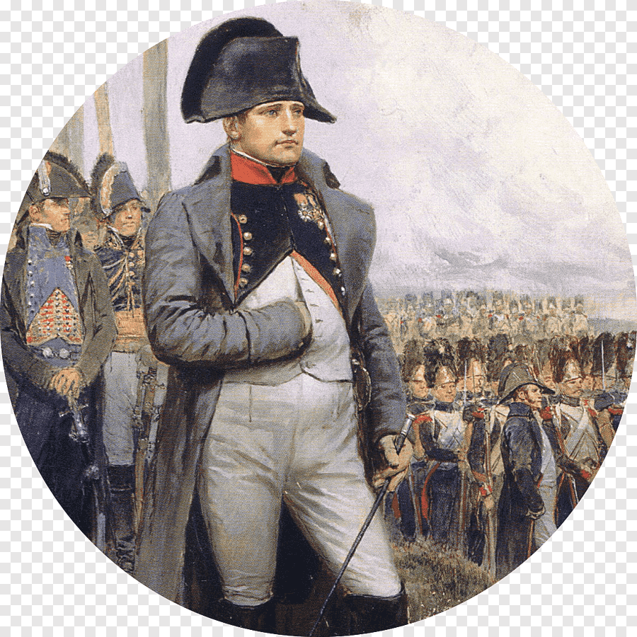
Get ready for small man’s syndrome at its finest! We will meet one of the greatest military generals in history (my personal role model) and learn how in less than 20 years he conquered nearly all of continental Europe! You will have a chance to show your knowledge of this unit in a creative way instead of writing a unit test. We will also become soldiers & try out battlefield warfare.
Statement of Inquiry: Advances in scientific and technological innovations revolutionized the world and changed every aspect of modern life.
Unit 5 – Industrial Revolution (P. 228-263)
Ever wonder how we got the rights we enjoy as workers today (weekends, minimum wage, breaks) or the history of the factory system? We will explore the Industrial Revolution!
This will be the first unit where no one loses a head (however plenty of people, particularly children were mangled in machinery). You will know firsthand what it was like to work in a 19th century factory and be thankful you were born in the 21 century! You will also experience a true British tea service. Finally, we will also begin our historical lit circle unit where you will read a novel connected to the history we have studied.

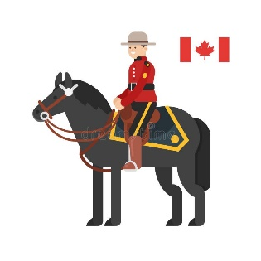
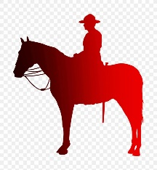
Oh Canada! Our Home and native land: Politics and History of North America
Canada: 1800-1919
Statement of Inquiry: Conflict can lead to a change in identity and global perspectives.
Unit 6 – Pre 20th C Canada and World War One (Counterpoints)
In this unit we will continue to study about how our geography has had an impact on our history and national identity. We will learn about how Canada became an independent (sort of) country and how to achieve unity we forced through a railway at the expense of Indigenous and Metis people. Finally, we will study the causes and impact of World War One on our country.
FINAL EXAM: History Passion Project: you will be given a chance to study a topic of your choice using the historical skills we have learned this semester. You will relate it to a statement of inquiry that we studied.

