SWAT Questions
- A. The person who was falsely accused of saying “let them eat cake” (Marie Antoinette)
B. The leader who was called short by the British (Napoleon)

- A. The place Napoleon unsuccessfully invaded and lost over 600 000 troops in the process (Russia)
B. Where the Industrial Revolution first began (Britain)

- A. A name of a World War One Battle Canadians engaged in (Ypres, Somme, Vimy Ridge, Passchendaele)
B. The year Canada confederated (1867)

- A. Name of the Metis Leader during the rebellions (Louis Reil)
B. Name of the Act in Canada that included Residential Schools (Indian Act)

- A. One of Canada’s 4 original provinces (Ontario, Quebec, Nova Scotia, New Brunswick)
B. Name of the leader of the revolutionary army in the American Revolution (hint, also their first president) (George Washington)

- A. Name of the opposing side to the Americans in the American Revolutions (Britain)
B. Name of Napoleon’s first wife (Josephine Bonaparte)

- A. Fate of Louis the 16 and Marie Antoinette (death by guillotine)
B. Where did Marie Antoinette and Louis the 16 live prior to the revolution in France (Versailles)

- A. War where British soldiers burnt down the white house (War of 1812)
B. Who won the 7 years War, and therefore Canada, in 1763 (Britain)

- A. What was a famous slogan of the American Revolution (No taxation without representation
B. What was a famous slogan of the French revolution (Liberte, Eqalite, Fraternite)

- A. What was the most famous weapon of the French Revolution (The guillotine)
B. Who paid almost all of the taxes in France prior to the revolution (The Peasants)

- A. What was the name of the King who built Versailles (King Louis the 14)
B. What famous prison was attacked in the French Revolution (The Bastille)

- A. What was the declaration signed during the American Revolution (The declaration of Independence)
B. What was the declaration signed during the French revolution (The Declaration of the rights of the man and the citizen)

- A. What was the most famous invention of the Industrial Revolution (steam engine)
B. What was the most famous thing that ran on steam (trains)
14. A. What was the name of the leader of the Reign of Terror in France (Robespierre)
B. What was the name of Napoleon’s favorite historical empire (the Romans)

15. A. What was the name of Canada’s army in World War One (The Canadian Expeditionary Force)
B. What was the name of the treaty that ended World War One (The Treaty of Versailles)

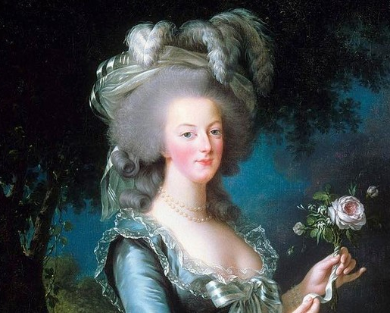

Marie Antoinette

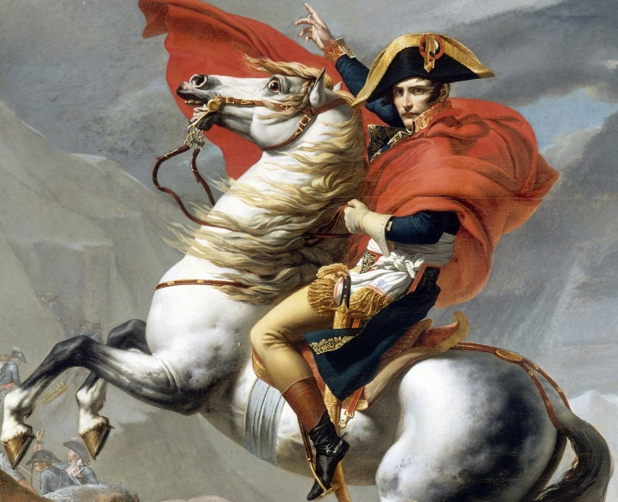

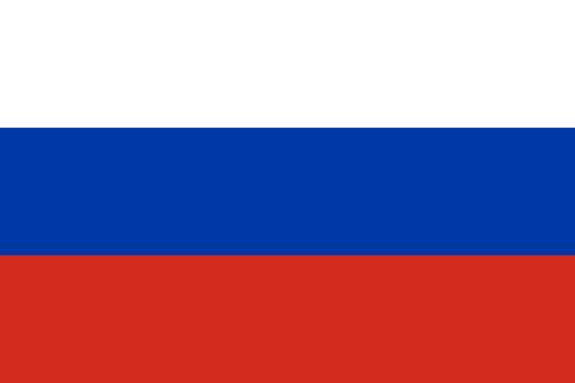
Napoleon
Russia

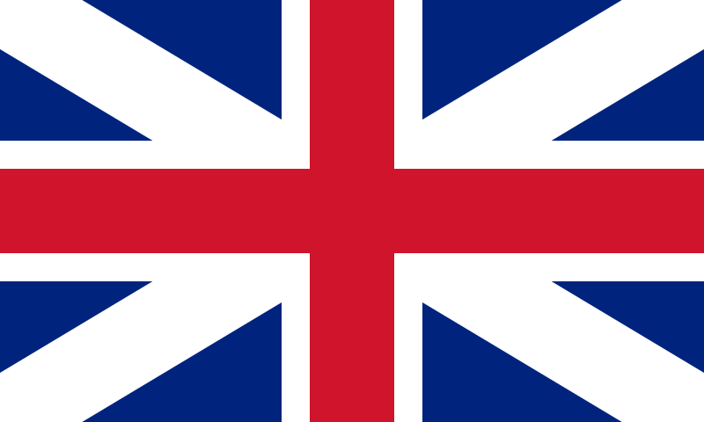

Britain
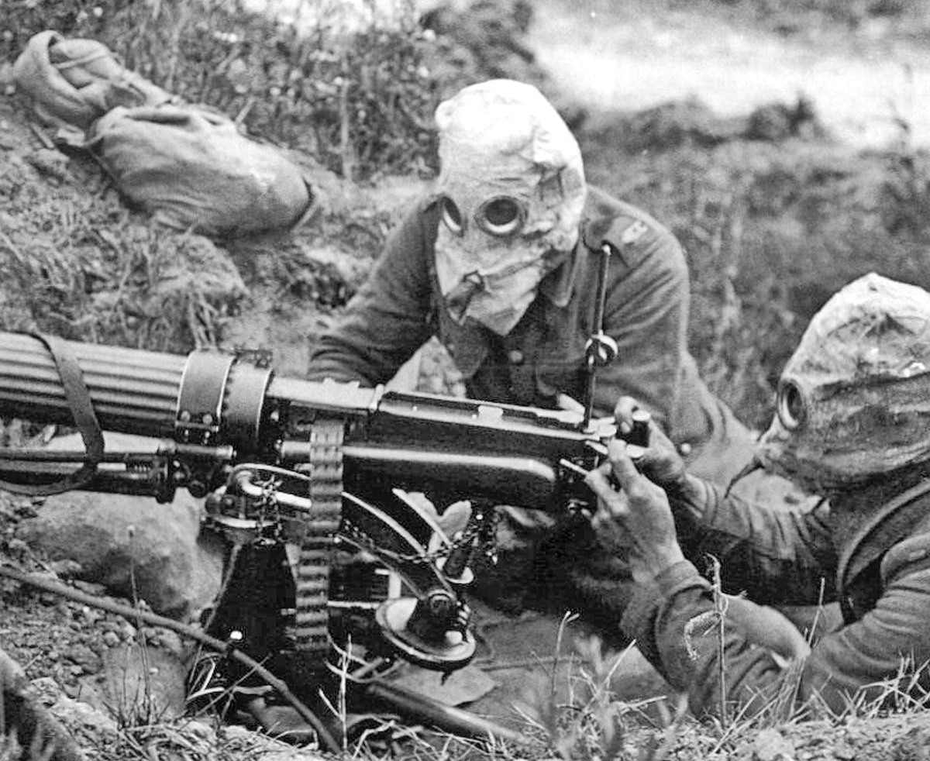

Somme

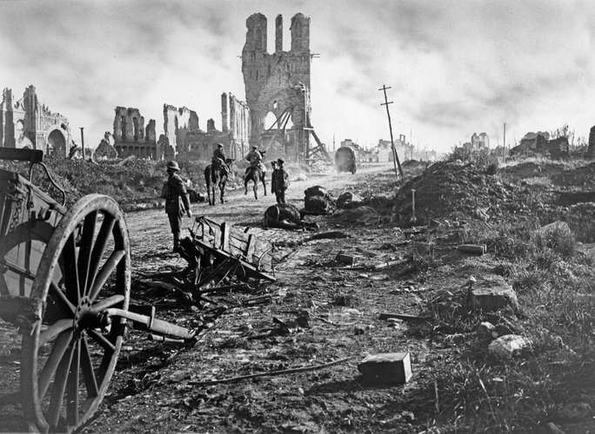
Passendaele

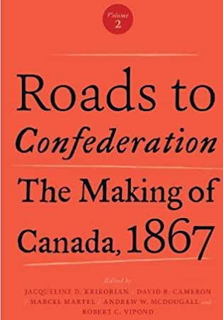
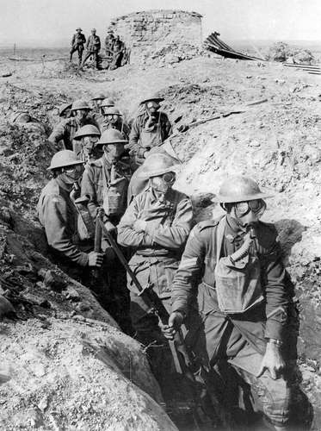
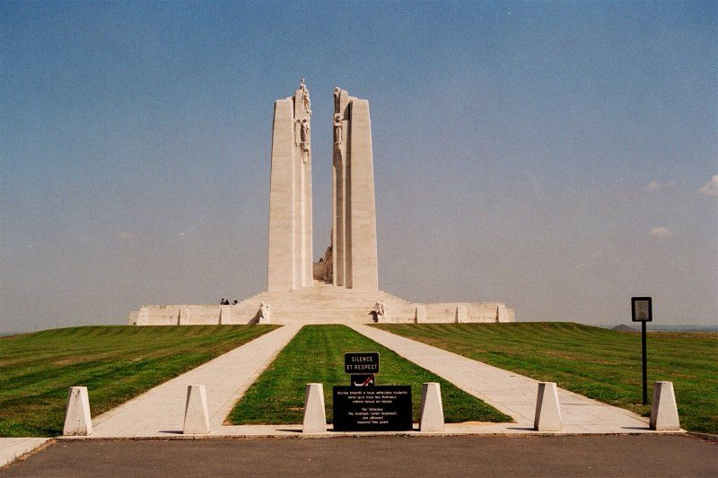
1867
Vimy Ridge
Ypes

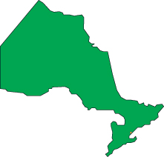
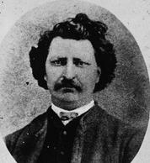
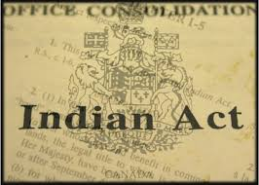
Ontario
Louis Riel

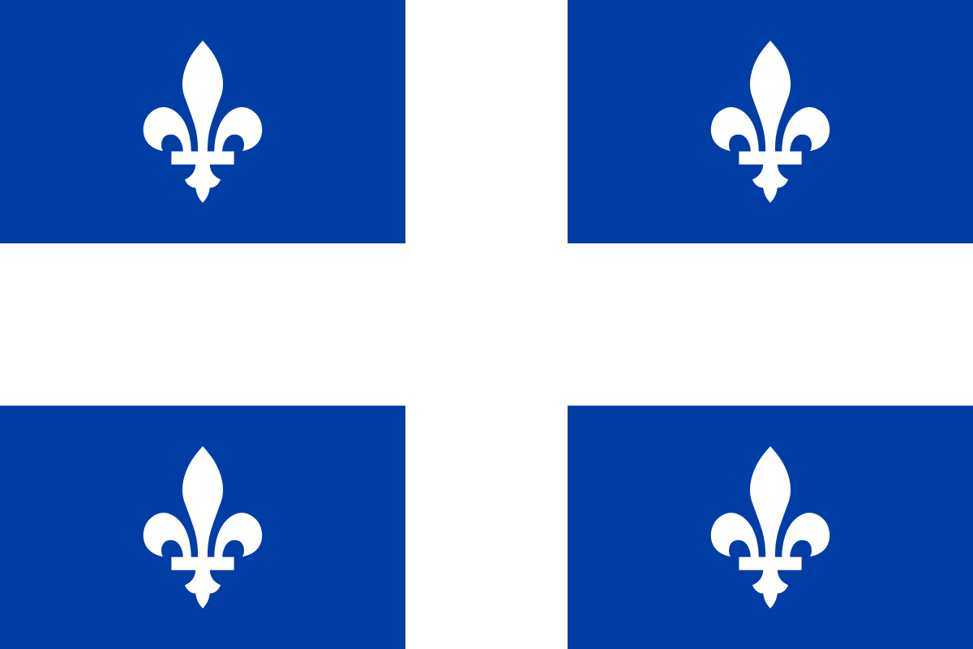

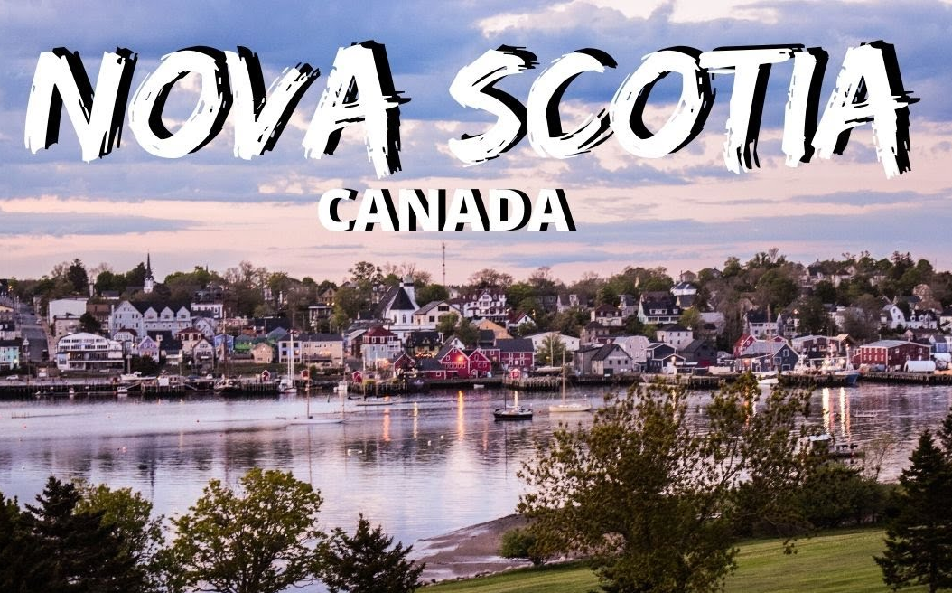
Quebec

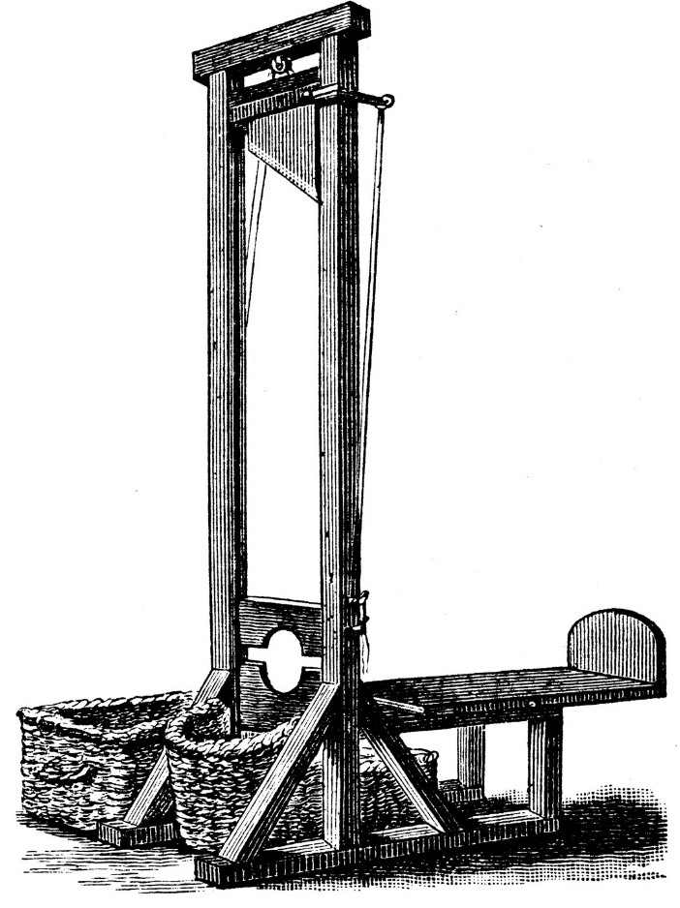
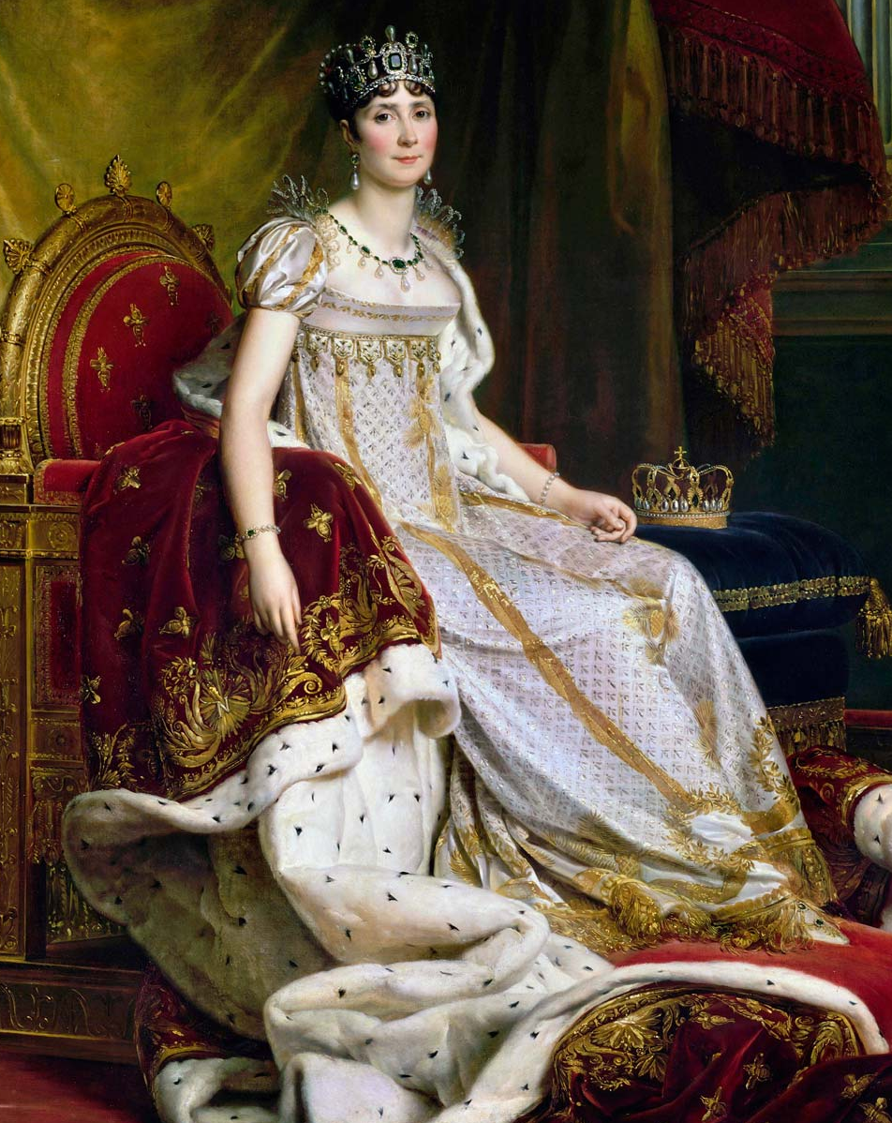
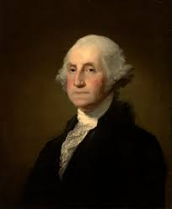
Guillotine
Joesphine Bonaparte
George Washington

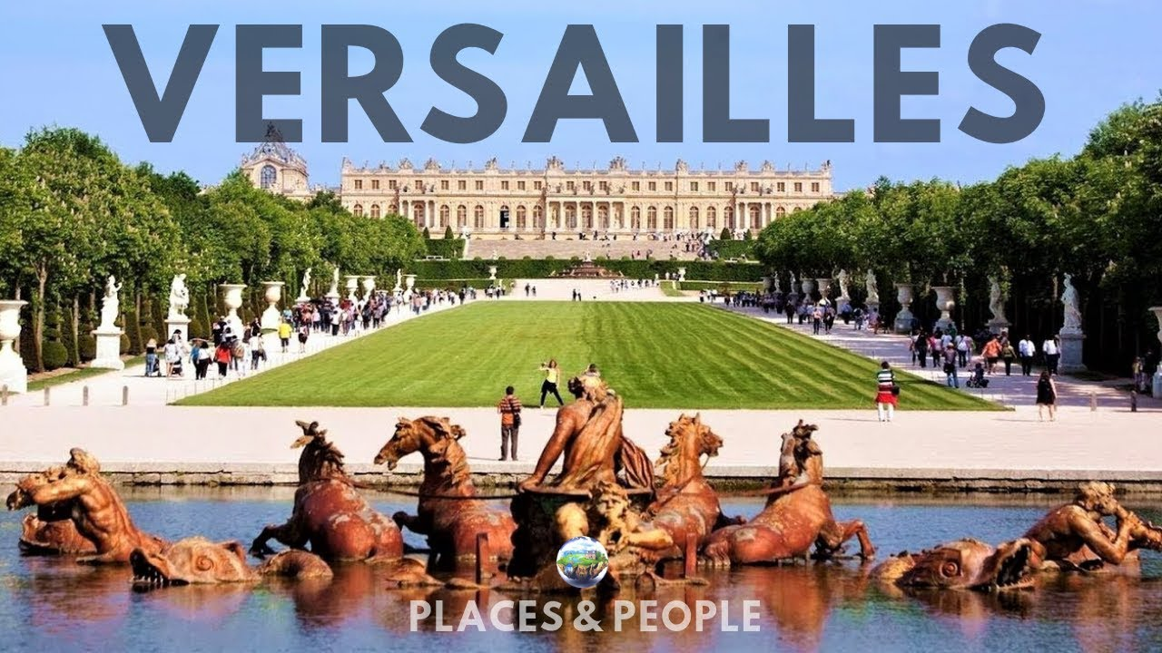

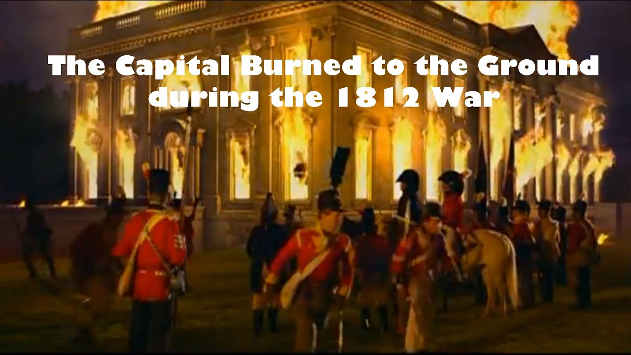

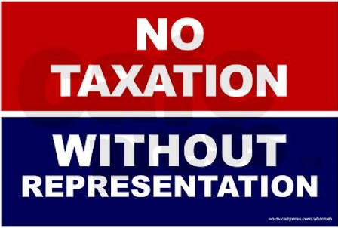

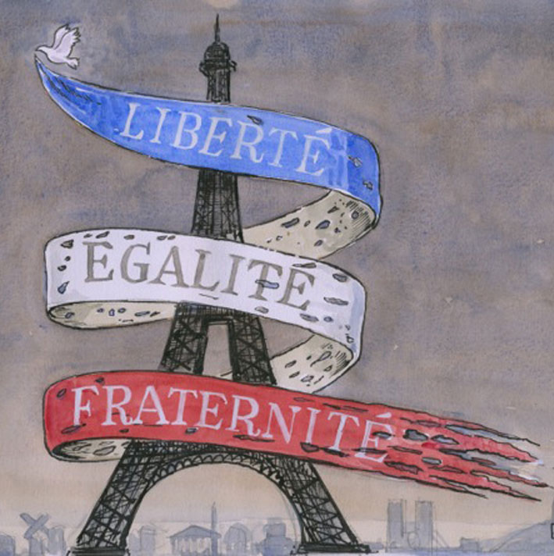
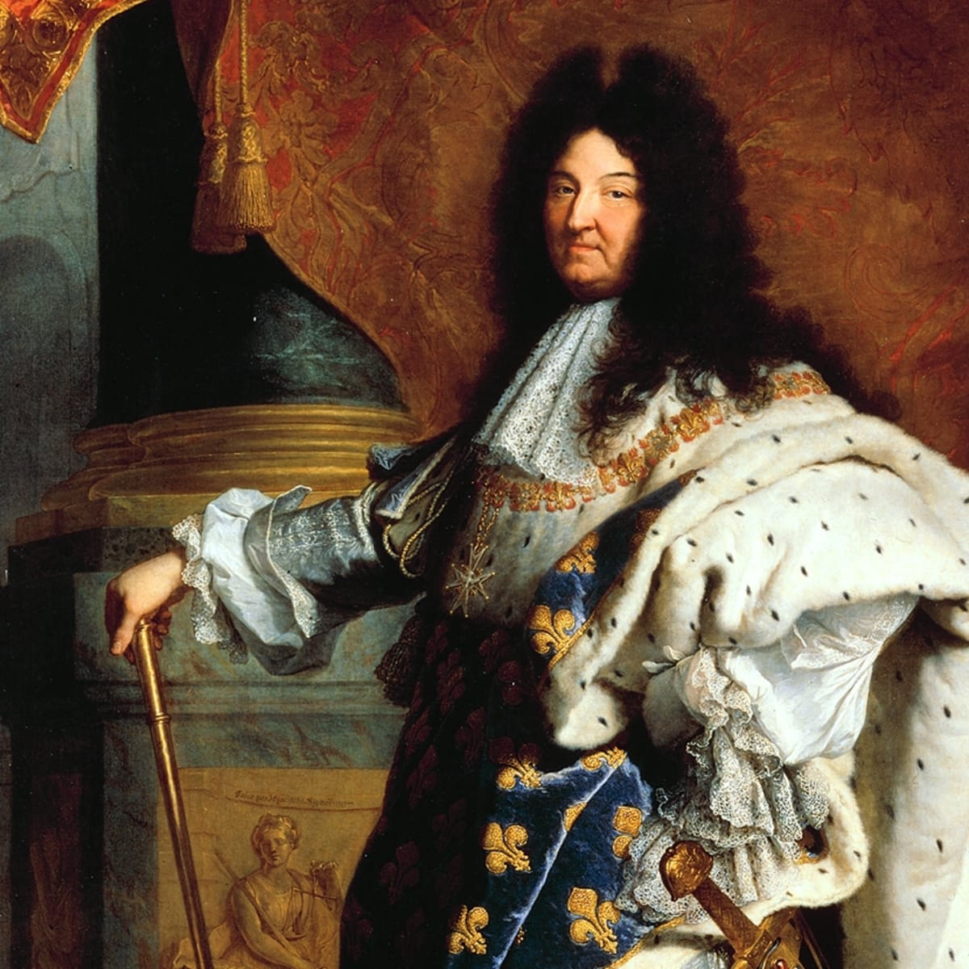
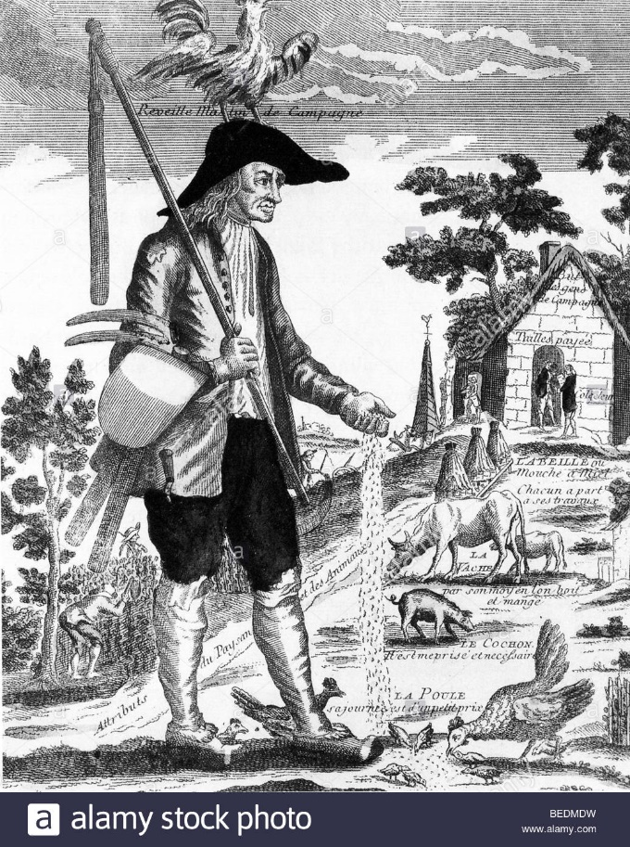
King Louis the 14
The Peasants

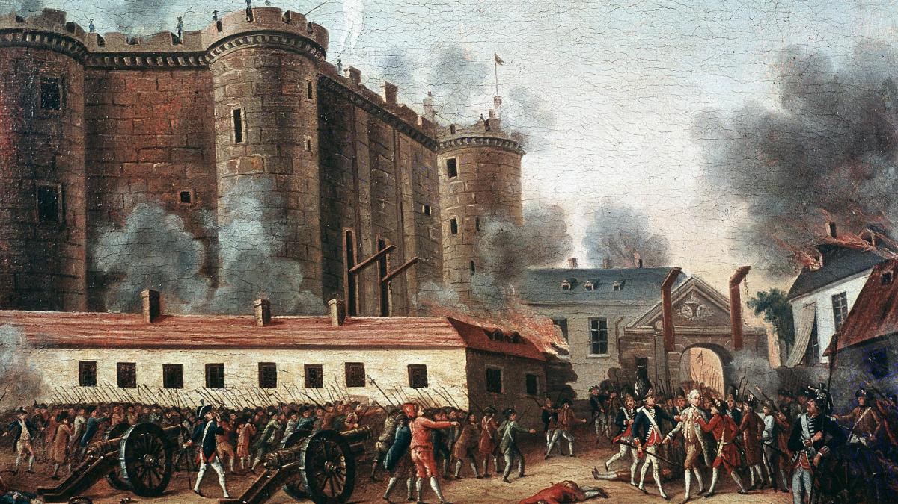

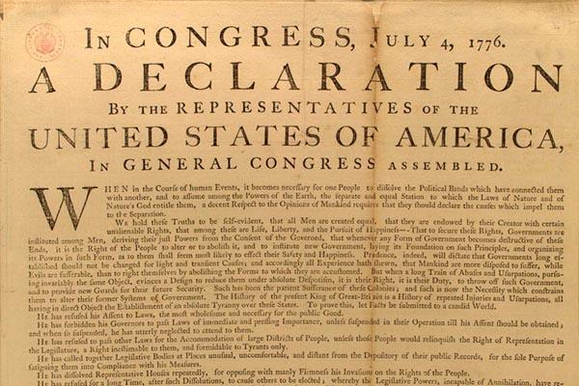
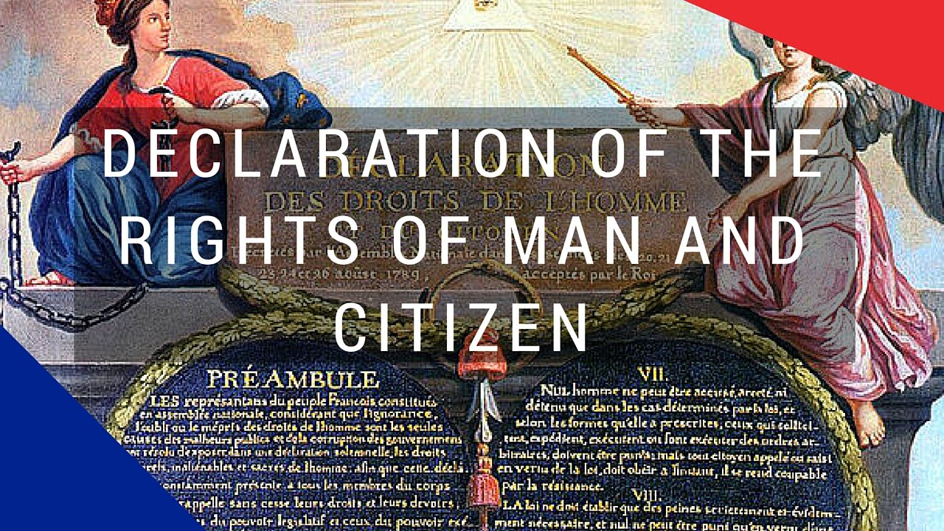
The Bastille

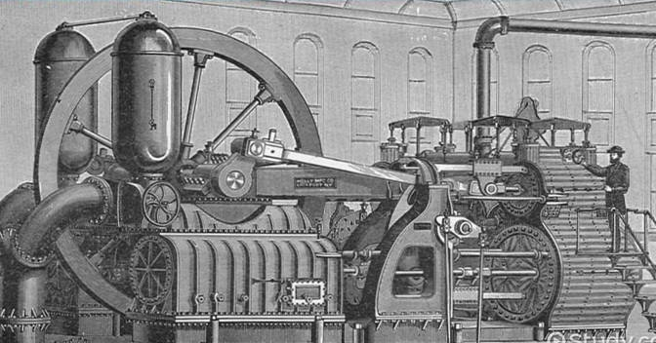
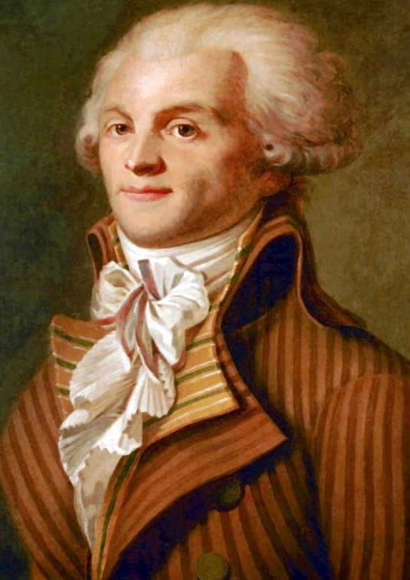
Robespierre
Train
Steam Engine

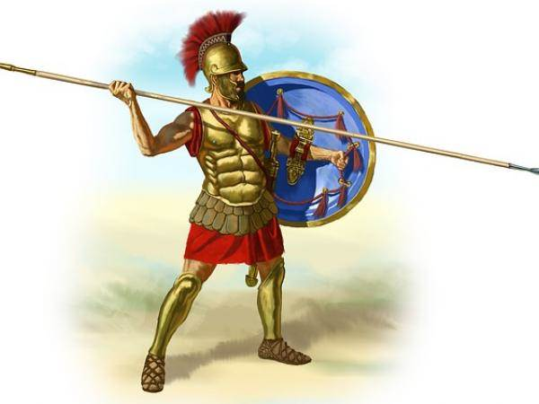
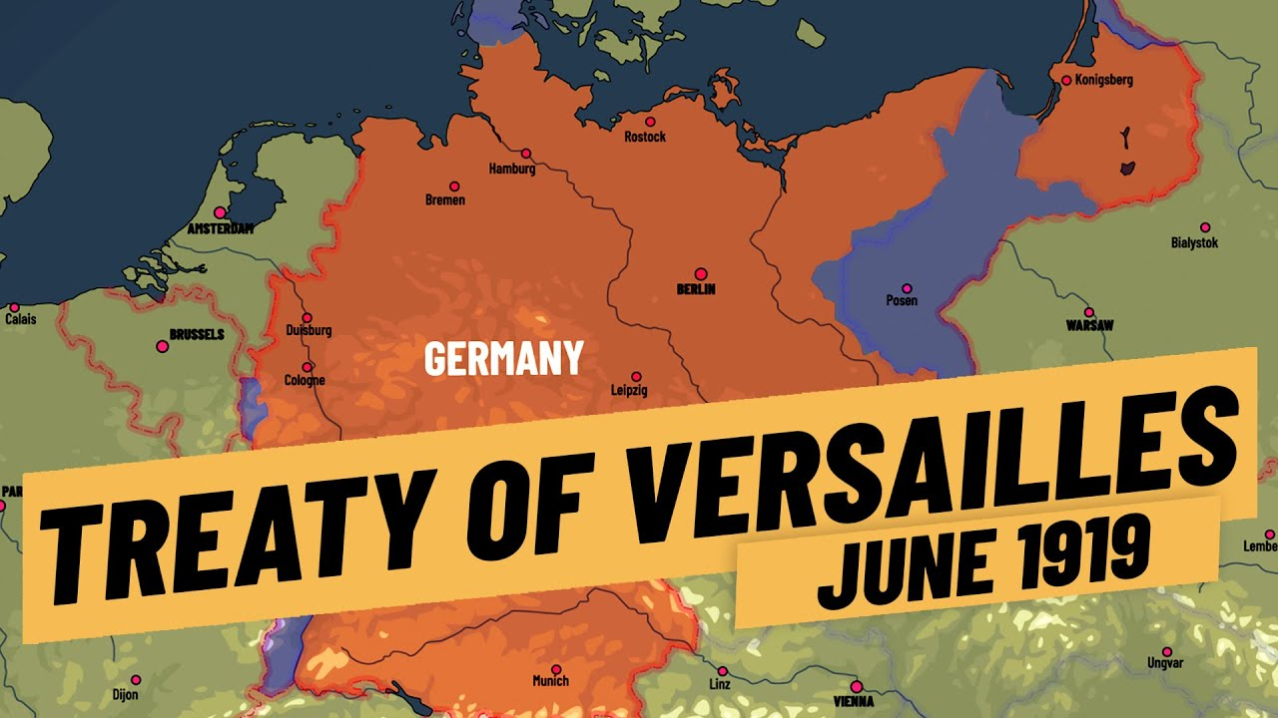
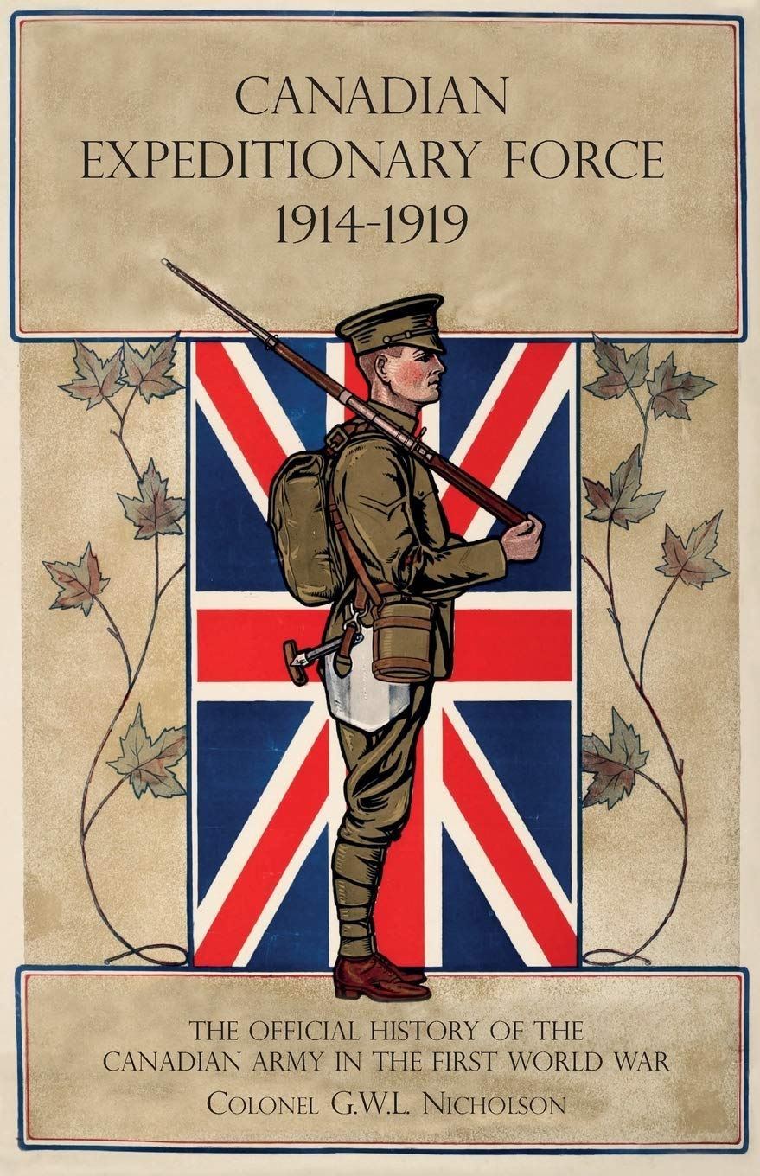
Romans

