The 13 Colonies and the Quebec Act
Use the maps on pages 159, 299 & 303 to complete the blank map below
Identify the following features on this map by coloring & labeling:
All 13 colonies (shade in red) Rupert’s Land (shade in brown)
Spanish Louisiana (shade in yellow) Native land (shade in green)
5 Great Lakes (outline in blue) Gulf of Mexico (outline in blue)
Atlantic Ocean (outline in blue) Proclamation Line (outline in red)
St. Lawrence River (outline in blue) Montreal Nova Scotia
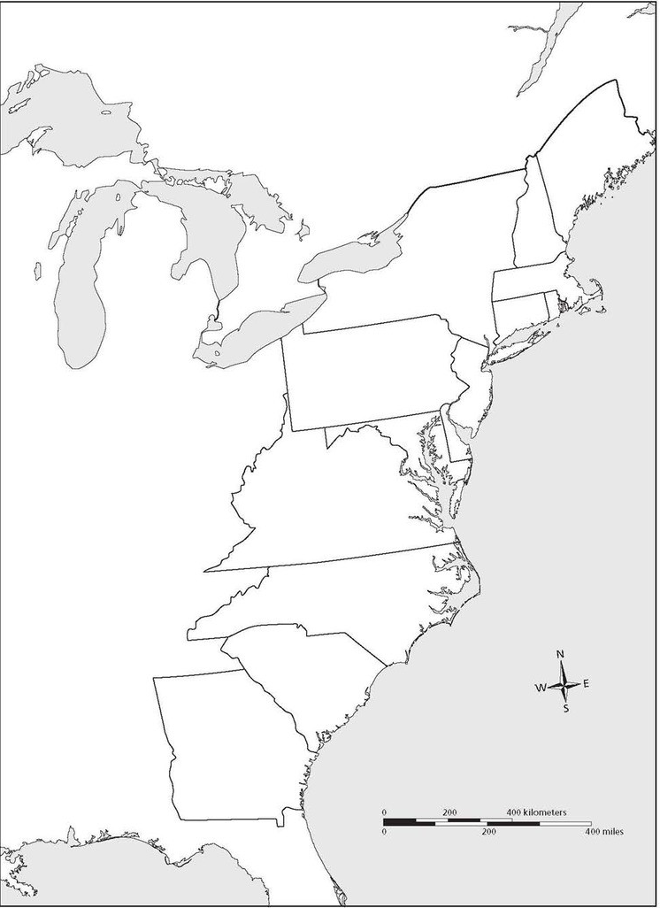
Quebec West Florida East Florida

