Ugly French Revolution and/or Napoleon Sweater or T-shirt design Project!
Mr. Fleming Name:

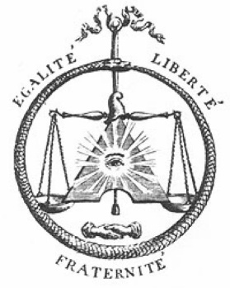
This is an option for one of your assignments during this unit, do not feel obligated to buy the shirt to submit it, you can design it using a website using their creative images or design your own with images you find online or by printing out the shirt template at the bottom of this assignment and drawing on them! Your choice!
If you choose to use the online option, simply save your work, and print it or take a picture of it and send it to me. You may work with a partner if you wish. The website I used for the example below is https://www.customink.com/products/t-shirts/4 you may use another website of your choosing, your shirts however need to fill more space on the shirt than mine did. I want a nice big elaborate piece of art to show off your knowledge of the French Revolution/ Napoleon.
Expectations
- Your theme is the French Revolution and/or Napoleon
- You must have at least 4 images on the Shirt or if you are drawing on the shirt it must take up the whole front!
- The back of your shirt must tell me in point form some key events that took place in the Revolution or Key things Napoleon did
Marking Rubric below with examples and templates to follow.
Criterion C: Communicating
Achievement Level | Level Descriptor | Task-Specific Clarification
0 | The student does not reach a standard described by any of the descriptors below. | Add your own expectations here!
1-2 | The student:  - communicates information and ideas in a limited way, using a style that is limited in its appropriateness to the audience and purpose,  - structures information and ideas according to the specified format in a limited way,  - documents sources of information in a limited way.
3-4 | The student:  - communicates information and ideas satisfactorily by using a style that is somewhat appropriate to the audience and purpose,  - structures information and ideas in a way that is somewhat appropriate to the specified format,  - sometimes documents sources of information using a recognized convention.
5-6 | The student:  - communicates information and ideas accurately by using a style that is mostly appropriate to the audience and purpose,  - structures information and ideas in a way that is mostly appropriate to the specified format,  - often documents sources of information using a recognized convention.
7-8 | The student:  - communicates information and ideas effectively and accurately by using a style that is completely appropriate to the audience and purpose,  - structures information and ideas in a way that is completely appropriate to the specified format,  - consistently documents sources of information using a recognized convention.

Criterion A: Knowing & Understanding
Achievement Level | Level Descriptor | Task-Specific Clarification
0 | The student does not reach a standard described by any of the descriptors below. | Add your own expectations here!
1-2 | The student:  - uses limited relevant terminology,  - demonstrates basic knowledge and understanding of content and concepts with minimal descriptions and/or examples.
3-4 | The student:  - uses some terminology accurately and appropriately,  - demonstrates adequate knowledge and understanding of content and concepts through satisfactory descriptions, explanations and examples.
5-6 | The student:  - uses a range of terminology accurately and appropriately,  - demonstrates substantial knowledge and understanding of content and concepts through accurate descriptions, explanations and examples.
7-8 | The student:  - consistently uses a wide range of terminology effectively,  - demonstrates detailed knowledge and understanding of content and concepts through thorough accurate descriptions, explanations and examples.

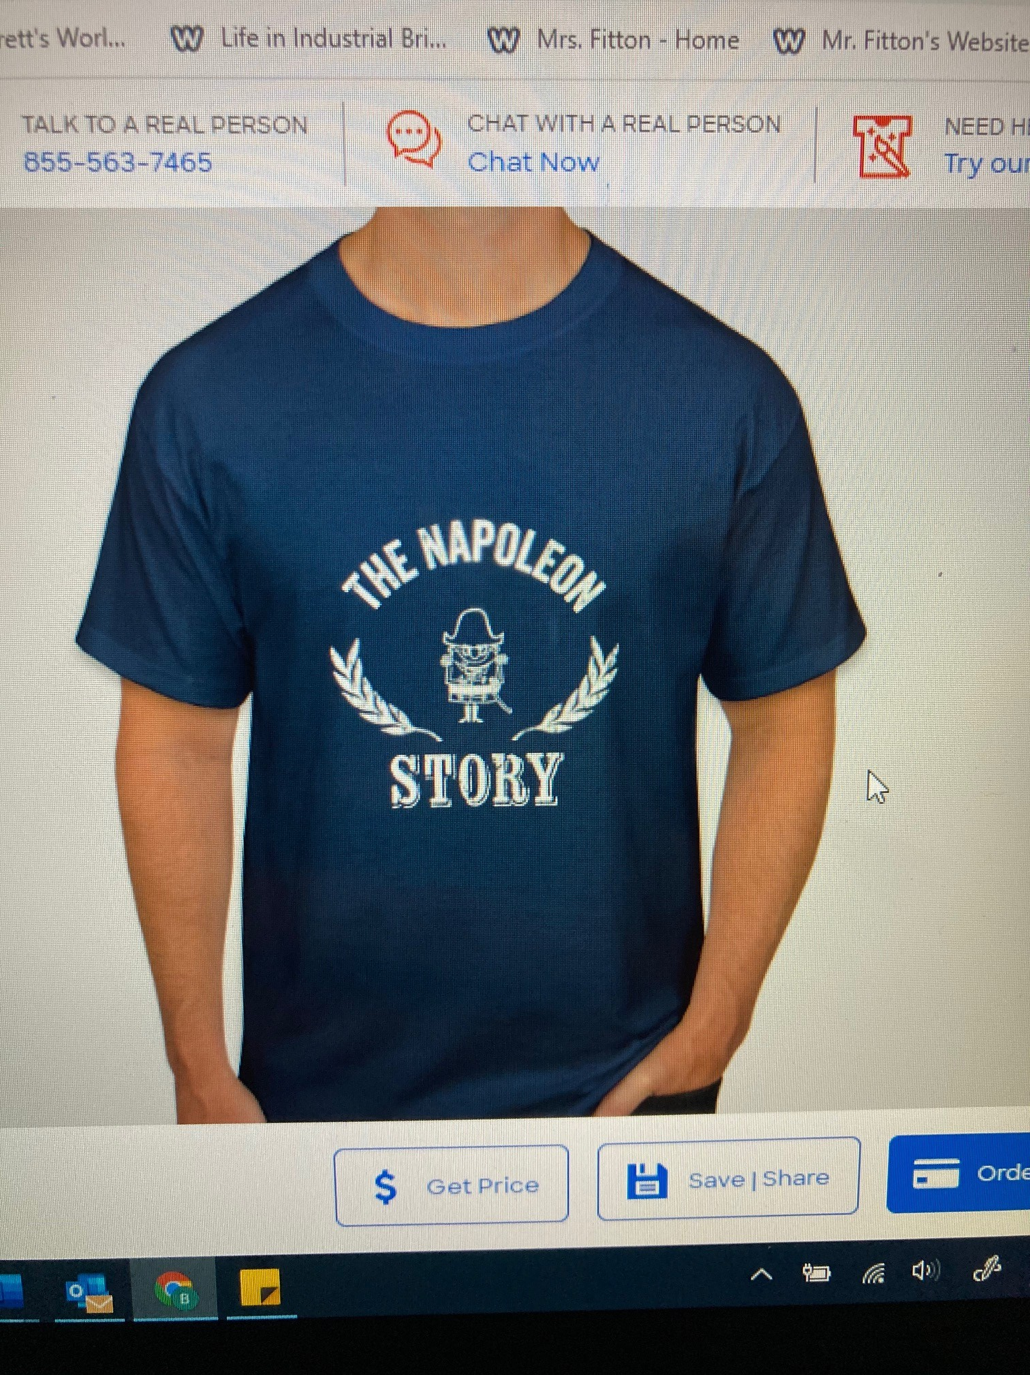
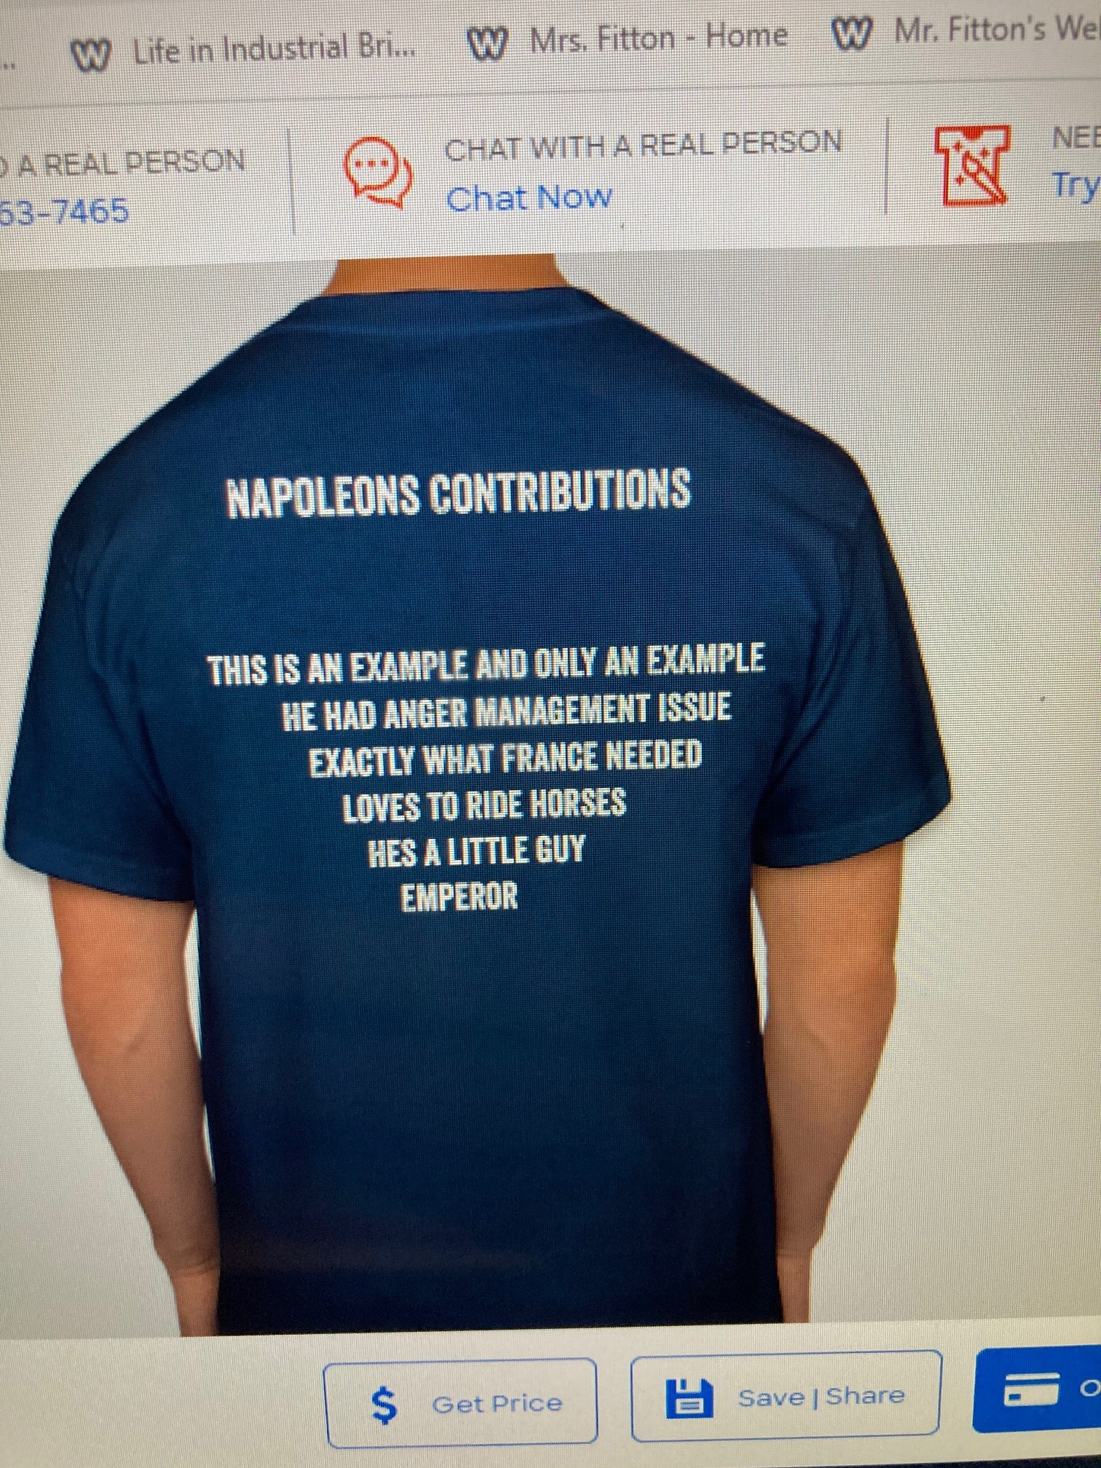

ugjh

