Socials 9 Name: ________________________
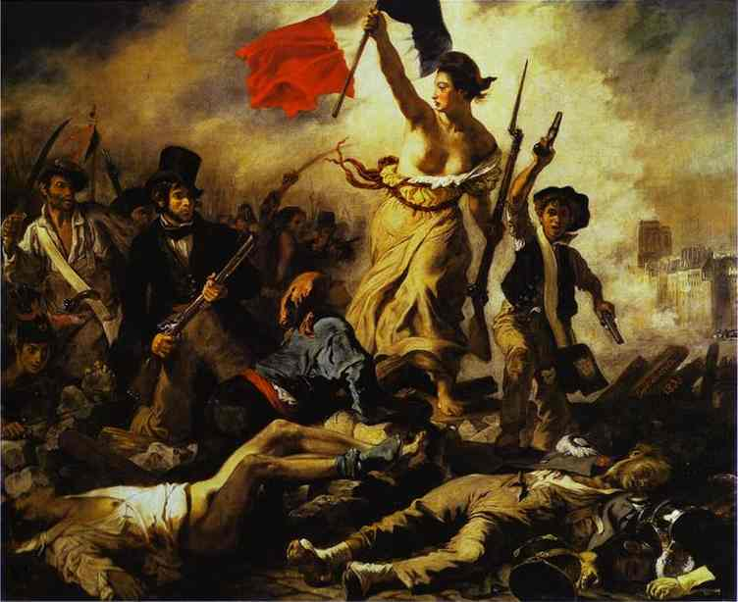
Napoleon and The French Revolution

“Viva La Vida” Coldplay

I used to rule the world
Seas would rise when I gave the word
Now in the morning I sleep alone

Some people think that this song is about The French Revolution and Napoleon. Keeping that in mind, read through the lyrics and:

1. Circle 2 things that show it is about the French Revolution. Explain why you circled them.

Explanation for first line:

Explanation for second line:

2. Make at least 2 predictions about Napoleon. Underline lines from the song that support your prediction

Predictions:

1.

2.

3. Now, watch the music video and record images that support both the conclusion that the video is about the French Revolution and Napoleon.

French Revolution

Napoleon
Sweep the streets I used to own

I used to roll the dice
Feel the fear in my enemies’ eyes
Listen as the crowd would sing
"Now the old king is dead! Long live the King!"

One minute I held the key
Next the walls were closed on me
And I discovered that my castles stand
Upon pillars of salt and pillars of sand

I hear Jerusalem bells are ringing
Roman Catholic choirs are singing
Be my mirror my sword and shield
My missionaries in a foreign field

For some reason I can not explain
Once you know there was never, never an honest word
That was when I ruled the world

It was the wicked and wild wind
Blew down the doors to let me in
Shattered windows and the sound of drums
People could not believe what I'd become

Revolutionaries wait
For my head on a silver plate
Just a puppet on a lonely string
Oh who would ever want to be King?

I hear Jerusalem bells are ringing
Roman Catholic choirs are singing
Be my mirror my sword and shield
My missionaries in a foreign field

For some reason I can not explain
I know Saint Peter won't call my name
Never an honest word
And that was when I ruled the world
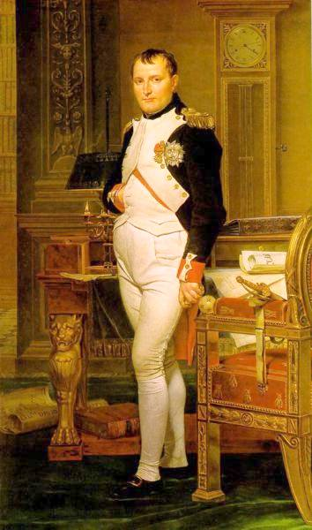
Hear Jerusalem bells are ringing
Roman Catholic choirs are singing
Be my mirror my sword and shield
My missionaries in a foreign field

For some reason I can not explain
I know Saint Peter will call my name
Never an honest word
But that was when I ruled the world.

